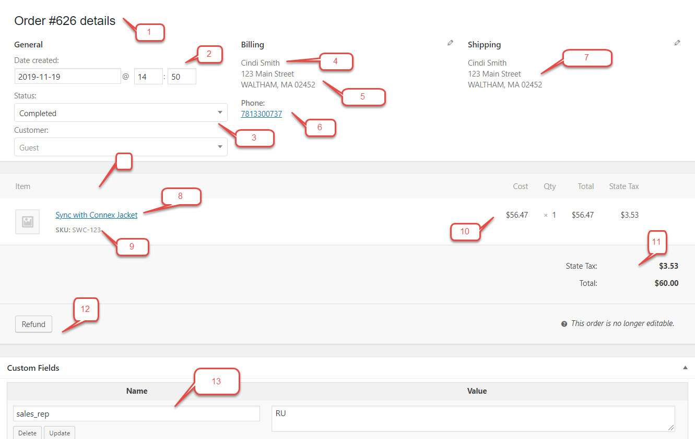
Number | WooCommerce | QuickBooks
1 | Order number | Order number
2 | Order date | Order date
3 | Order status | No mapping, but can be used to map other fields with our rules engine.
4 | Billing name | Maps to the QuickBooks display name as or customer name in QuickBooks. Used to match customers.
5 | Billing address with company | Customer and order billing address.
6 | Billing phone | Customer phone
7 | Shipping address | Shipping address on order and customer.
8 | Item name | Order item description
9 | SKU | QuickBooks item name or SKU, if QuickBooks Online. Used for product matching.
10 | Unit price and quantity | Unit price and quantity
11 | Tax | Mapped as a line item or you can use QuickBooks tax codes to recalculate. For each item that is taxable, we mark the item as taxable. If taxable, then we add tax. We use the line item tax to determine taxability.
12 | Partial or full refunds | Credit memos or refund receipts.
13 | Custom fields | Maps to QuickBooks custom fields or other areas, such as sales rep. You can use our rules engine to map them.

