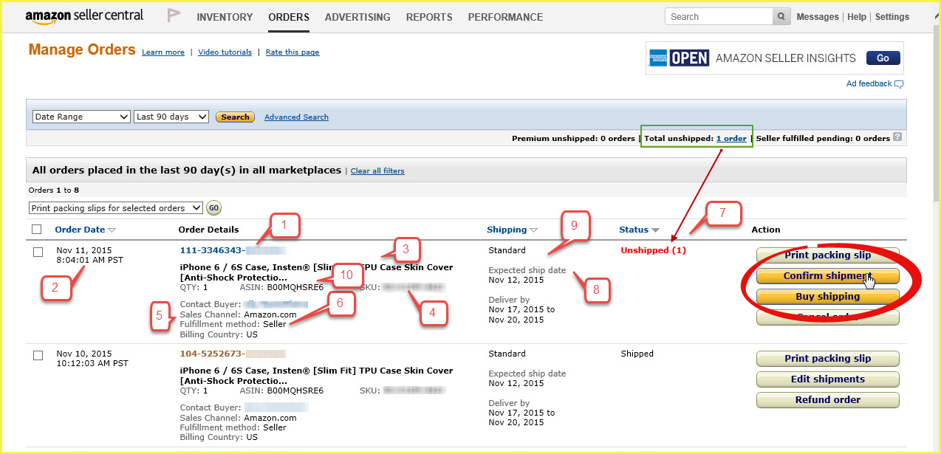

Number | Amazon | QuickBooks
Not shown | Billing name | Matches to QuickBooks customer or display name as field. Used for customer matching.
Not shown | Billing address | Customer billing and order billing address.
Now shown | Shipping name | Customer and order shipping address. Can be used for customer matching, if you choose shipping name. Billing name is the default.
Not shown | Payment method | Defaults to other in QuickBooks.
Not shown | Amazon fees | If the order is shipped, then we sync the Amazon fees if you configure Connex.
1 | Order number | Order number
2 | Order date | Order date
3 | Item name | Order item description. We only pull the item name, if you sync orders before they ship. Otherwise, we can pull the item name from QuickBooks, if the SKU matches the QuickBooks product.
4 | SKU | Used to match QuickBooks products by item name or website SKU.
5 | Selling channel | No QuickBooks mapping, but used to map other fields like inventory site. Says AFN for Amazon FBA and MFN for merchant fulfilled.
6 | Billing country | Billing country
7 | Order status | We pull shipped orders by default. No QuickBooks mapping, but can be used to map other fields.
8 | Ship date | Ship date
9 | Shipping method | Shipping method
10 | ASIN | No mapping, but can be used for rules. Contact us about pulling this field.

