Example Field Mapping with Shopify
Here are the most common fields with the rules engine that you can compare for rules.

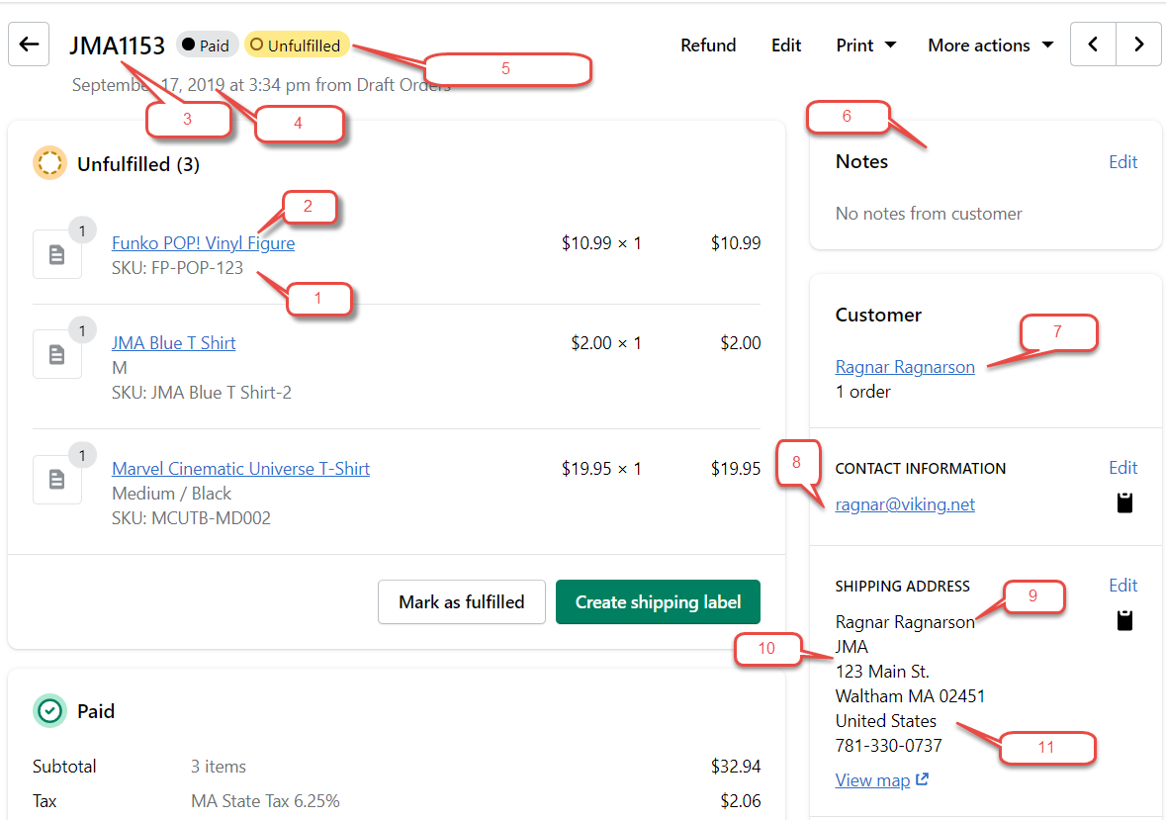

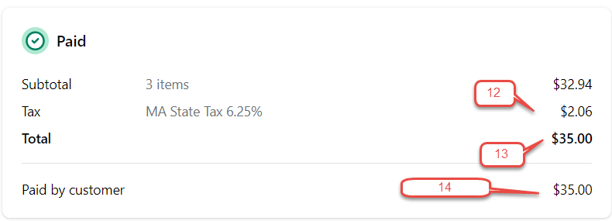
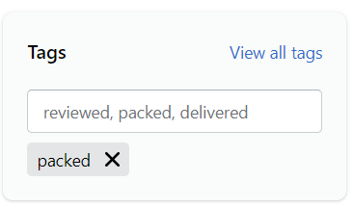

Number | Connex Field Name | Description
1 | SKU | QuickBooks item name or SKU, if QuickBooks Online.
2 | Name | QuickBooks item description. If no SKU, you can add a rule to map item name to the QuickBooks item name or SKU field.
3 | Order Number | QuickBooks order number.
4 | Creation Date | QuickBooks order date.
5 | Order Status | Never mapped to QuickBooks. Used to compare fields.
6 | Private Notes | Mapped to the QuickBooks private notes field.
7 | Billing Full Name | Used for customer matching. Mapped to the QuickBooks display name as field.
8 | Billing Email | Mapped to the QuickBooks customer email field. Used for rule comparisons.
9 | Shipping Full Name | Used for customer matching, if the user selects shipping name. Mapped to the QuickBooks display name as field.
10 | Billing and Shipping Company | Mapped to the QuickBooks billing company name and shipping name fields.
11 | Billing and Shipping Country | Using the rules engine, country can be omitted from the order. Billing or shipping country can be used to compare rules.
12 | Order Tax | Mapped as a line item, if the user selects this setting.
13 | Order Total | Used to compare rules. Connex sends line items to QuickBooks and QuickBooks calculates the order total.
14 | Order Balance | Used to compare rules. The amount that the customer must owes.
15 | Order Tags | Used to compare rules. An order can have multiple tags.
16 | Tracking details | Brought in as a line item
17 | Shipping Carrier | Brought in as a line item
18 | Shipping Cost | Brought in as a line item

