Example Field Mapping with ShipStation
Here are the most common fields with the rules engine that you can compare for rules.

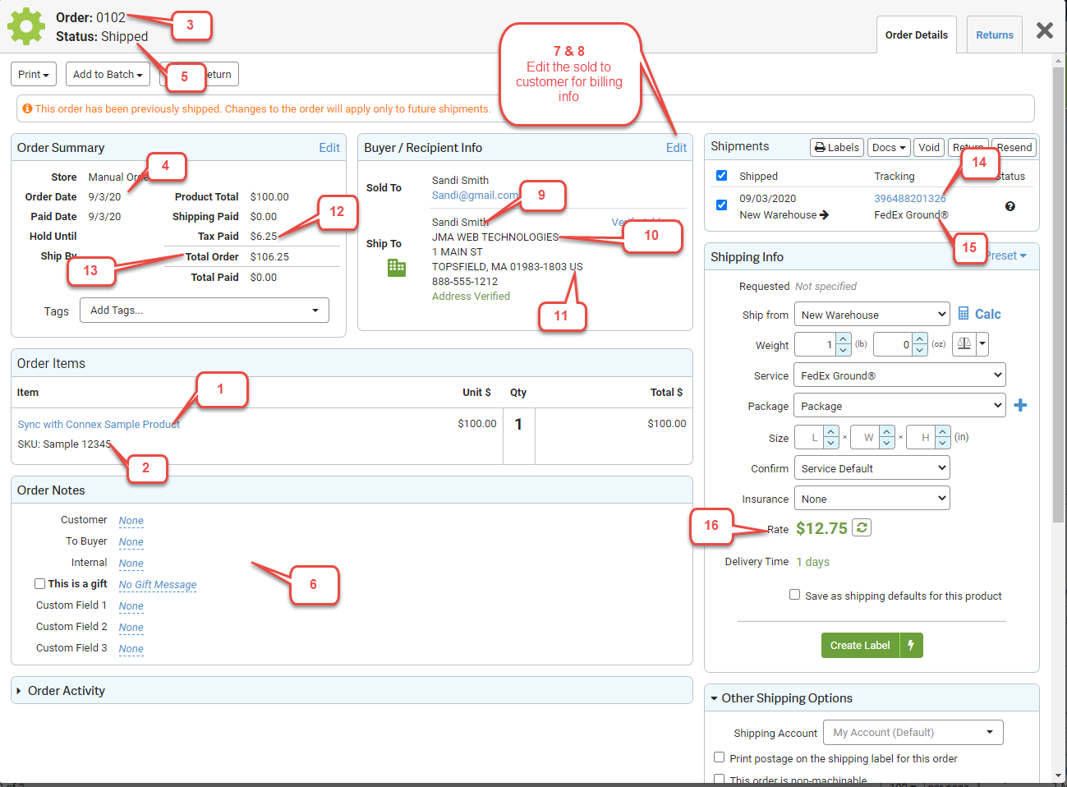

Number | Connex Field Name | Description
1 | SKU | QuickBooks item name or SKU, if QuickBooks Online.
2 | Name | QuickBooks item description. If no SKU, you can add a rule to map item name to the QuickBooks item name or SKU field.
3 | Order Number | QuickBooks order number.
4 | Creation Date | QuickBooks order date.
5 | Order Status | Never mapped to QuickBooks. Used to compare fields.
6 | Notes | Used to map notes by rules
7 | Billing Full Name | Used for customer matching. Mapped to the QuickBooks display name as field.
8 | Billing Email | Mapped to the QuickBooks customer email field. Used for rule comparisons.
9 | Shipping Full Name | Used for customer matching, if the user selects shipping name. Mapped to the QuickBooks display name as field.
10 | Shipping Company | Mapped to the QuickBooks shipping company and shipping name fields.
11 | Shipping Country | Using the rules engine, country can be omitted from the order. Billing or shipping country can be used to compare rules.
12 | Order Tax | Mapped as a line item, if the user selects this setting.
13 | Order Total | Used to compare rules. Connex sends line items to QuickBooks and QuickBooks calculates the order total.
14 | Tracking Number | Brought in as a line item in QB
15 | Shipping Method | Brought in as a line item in QB
16 | Shipping Rate | Brought in as a line item in QB
17 | Ship Date | QuickBooks Ship Date

