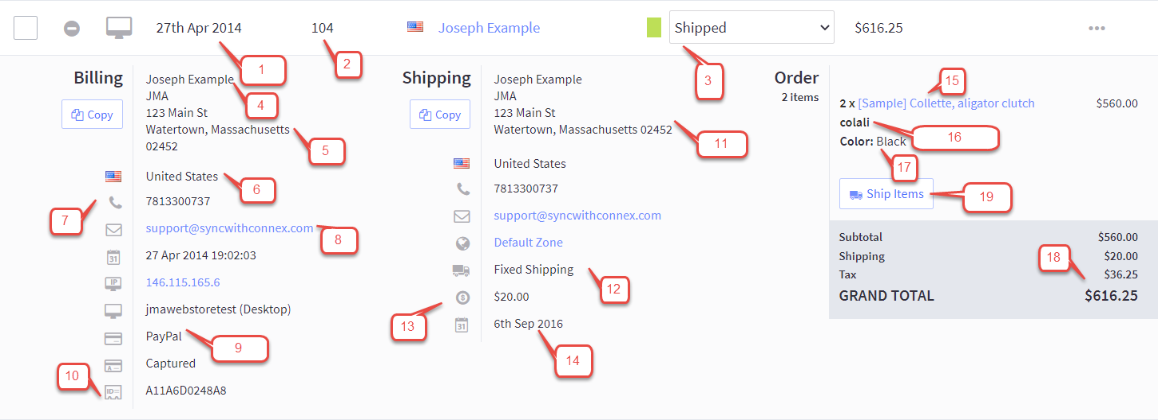
Number | Bigcommerce | QuickBooks
1 | Order date | Order date
2 | Order number | Order number
3 | Order status | No mapping, but can be used to map other fields with our rules engine.
4 | Billing name | Used to match customers in QuickBooks’ display name as or customer name field.
5 | Billing address | QuickBooks billing address field on order and new customer.
6 | Billing country | QuickBooks billing country field.
7 | Billing phone | QuickBooks customer phone.
8 | Billing email | QuickBooks customer email.
9 | Payment method | Payment method
10 | Payment reference number | Can be mapped to the payment ref. number in QuickBooks using our rules engine.
11 | Shipping address | Customer shipping address and order shipping address.
12 | Shipping method | Shipping method
13 | Ship date | Shipping date
14 | Shipping amount | Line item as shipping amount. Item name is the shipping method.
15 | Item name | Order item description.
16 | SKU | Item name or SKU, if QuickBooks Online. Used to match products in QuickBooks.
17 | Options | Appended to item description.
18 | Tax | Mapped as a line item or you can map a QuickBooks tax code.
19 | Tracking number | QuickBooks tracking number field or a line item with the tracking number.

