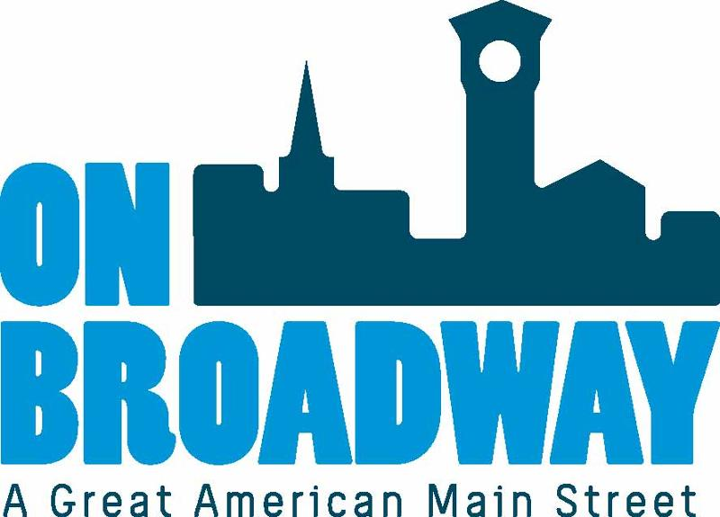
FOR IMMEDIATE RELEASE 12/16/21
Matt Valiquette
Executive Director
Bay Area Workforce Development Board
920-327-8732
mvaliquette@bayareawdb.org
Brooke Hafs
Marketing Director
On Broadway, Inc.
920-680-1226
brooke@onbroadway.org

Bay Area Workforce Development Board receives $70,000 grant to support opportunity youth
GREEN BAY, Wis. – The Bay Area Workforce Development Board has been awarded a $70,000 grant from the J.J. Keller Foundation, Inc. for their Transition to Success program to help support opportunity youth who are transitioning into independent living as an adult in the greater Green Bay area.
The Bay Area WDB will use these grant funds for educational, scientific, literary, or other charitable purposes. The goal is to provide mutually respectful, trusting relationships to assist vulnerable young people successfully transition into adulthood and obtain meaningful, self-sustaining employment.
The Transition to Success program is a multi-organization collaborative that not only helps youth navigate an entirely different system of care in adulthood, but it also maintains the connections in their personal and community life offering stability, continuity and support after turning 18.
"Nearly every single penny of this important award will go directly to disadvantaged Greater Green Bay community young people needing additional assistance (i.e. housing, basic needs, supportive services, childcare assistance, transportation assistance, vocational training etc.) to successfully transition into adulthood and achieve self-sufficiency and independence," said Valiquette. "The Bay Area WBD provides comprehensive, holistic workforce development services and programs to the workforce community. The J.J. Keller Foundation award provides tremendous flexibility and agility, enabling our collaboration to 'bridge gaps' that traditional state and federal funded programs lack. We 'braid' and leverage multiple funding streams to achieve a more streamlined and comprehensive service delivery mode."
The Bay Area Workforce Development Board is located in the Broadway District at 520 North Broadway in Suite 320.
About The Bay Area Workforce Development Board
The Bay Area WDB is one of eleven Wisconsin workforce development areas established in 1998 to address local economic workforce issues. Bay Area WDB, a non-profit corporation, is the fiscal and administrative agent for funds and programming designed to deliver locally customized job training and workforce development initiatives for in-demand industry sectors including manufacturing, construction, healthcare, insurance/finance, transportation, information technology, as well as sales, office/administrative and food preparation/serving. To accomplish its initiative, Bay Area WDB partners with College of Menominee Nation (CMN), Fox Valley Technical College (FVTC), Lakeshore Technical College (LTC) and Northeast Wisconsin Technical College (NWTC); and contracted service providers Family Services of Northeast Wisconsin, Forward Service Corporation, Great Lakes Training & Development Corp, and Newcap.
For more information, visit the website.
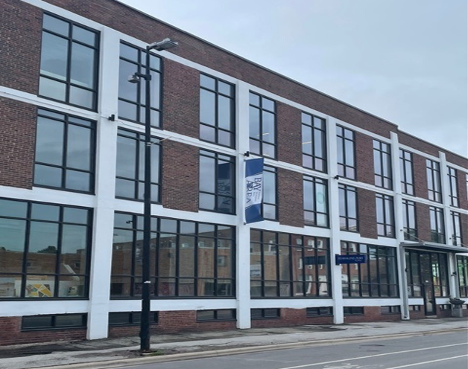
About On Broadway, Inc.
The historic Broadway District is the vibrant, engaging business and residential urban center of Northeast Wisconsin focusing on strategic marketing and staffing, funding and sustainability efforts, event development and coordination of promotions, business and residential recruitment and retention.
On Broadway, Inc. is a non-profit, community-based organization dedicated to strengthening the Green Bay community through economic development, historic preservation and promotion of downtown Green Bay’s Broadway District and the overall downtown community.

