FESI-BOND® WET Application Treatment Alternatives:

The FESI-BOND® wet reagent application is flexible and treatment methods can be designed to meet a variety of site specific needs. The methods can be modified to meet varying conditions while maintaining high daily output. Below are several typical treatment alternatives:

- In-situ Surficial Treatment (Depths < 3 feet)

In-situ treatment for soil depths up to 3 feet is considered surficial treatment. The soil area to be treated is loosened with the excavator bucket or tilling device to the appropriate depth. The FESI-BOND® reagents are applied to the surface, based on a volume of soil to weight calculation, at the application rate specified by the treatability study. The reagent and soil are mixed to ensure even contact of the stabilizers with the soil. Water is also applied to control dust and to assist with the chemical distribution. Stabilized soils can be sampled in place for TCLP analysis and could remain in place until the TCLP results confirm levels of leachable metals have been reduced to less than toxicity characteristic levels. The soils can then be loaded directly into dump trailers for off-site disposal or stockpiled for future disposal.

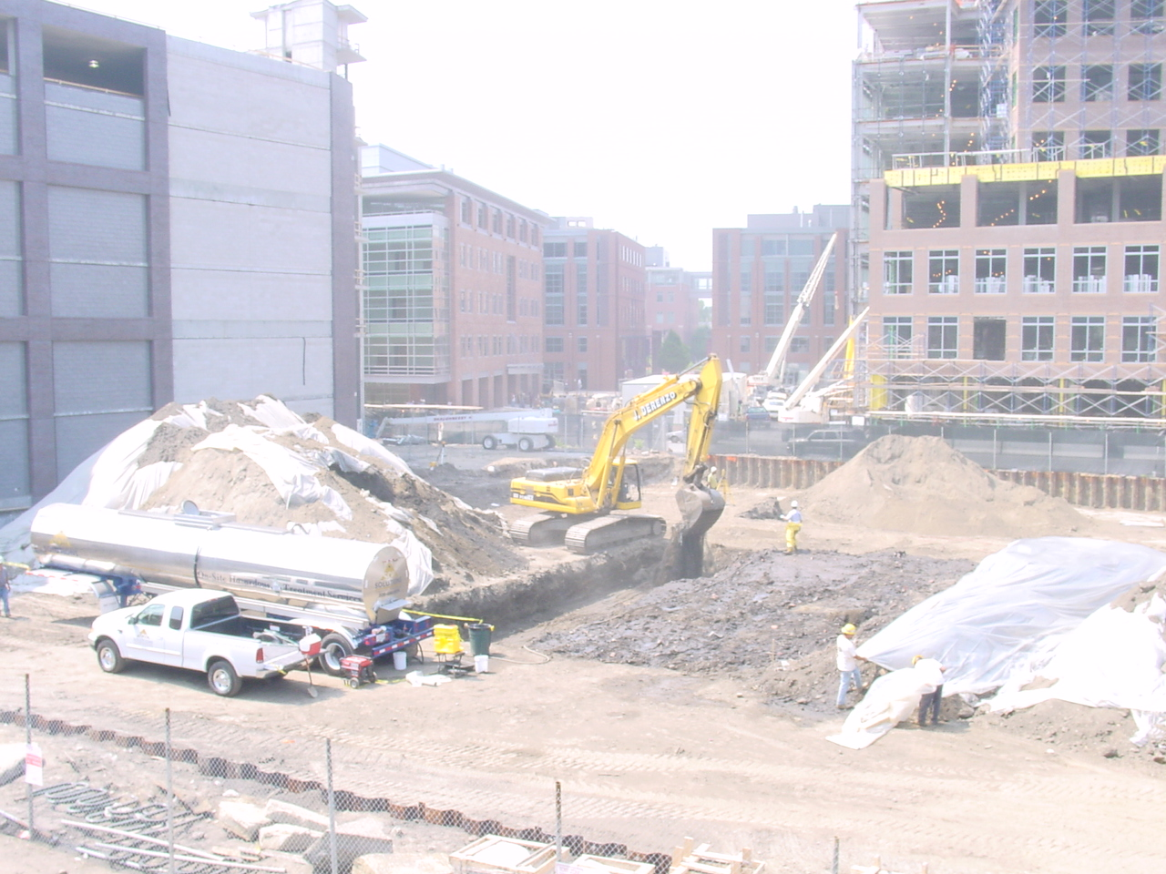
Figure 1 - In-Situ Methods

- In-situ - Deep Excavation (Depths > 3 feet)

In-situ treatment for soil depths greater than 3 feet are conducted in a series of lifts to control the volume of soil treated and the amount of reagent applied. As with the surficial treatment, the soil is loosened with the excavator bucket, the specified amount of reagent is added, and the reagent and soil are adequately mixed. It can be beneficial to stockpile the first couple of treatment cells outside of the treatment area, thereby creating a mixing pit that follows the treatment as you progress across the site. Buried debris and oversized materials can also be sprayed with the reagent as a treatment option. Confirmation sampling and loadout can be designed based on site specific requirements.

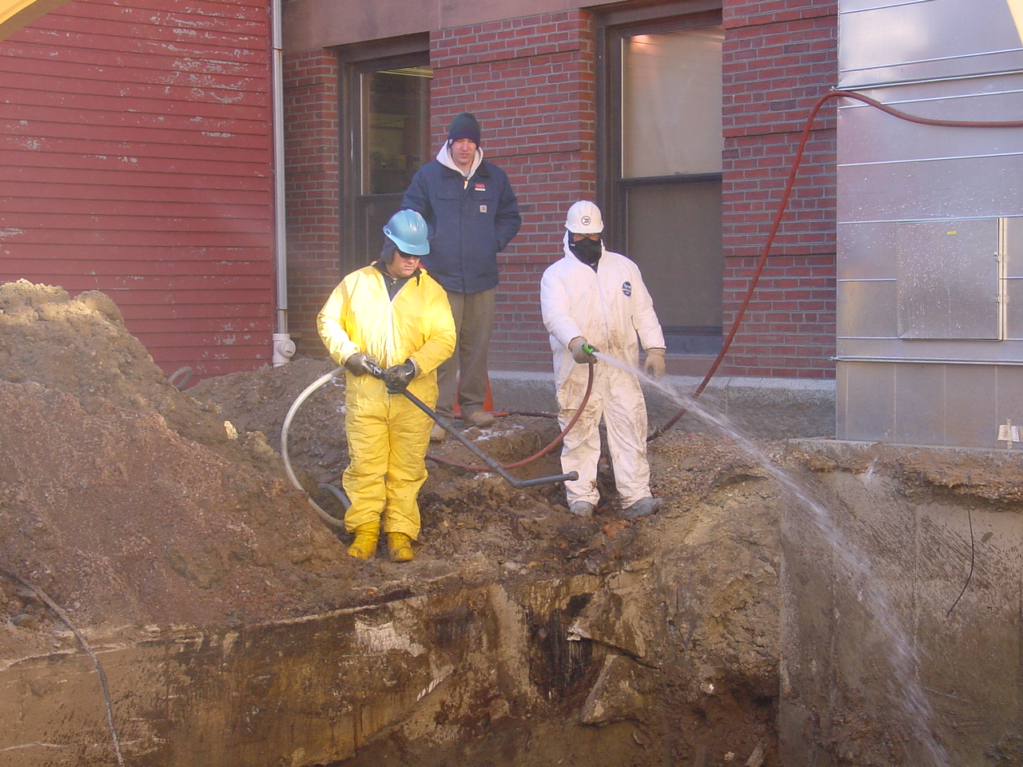
Figure 2 - Deep Excavation Methods

- In-situ – Below Water Table Options

In-situ treatment of soils below the water table can create some challenges. The extra water will make it difficult to meter the reagents into the soil at the proper rate. In this case, a mixing shelf above the water table can be used. Material from below the water table can be excavated and placed in an area above the water table and excess water is decanted. Treatment reagents can be applied at the appropriate rates and mixing performed. Stabilized soils would likely be stockpiled until confirmation testing is completed.

- Ex-situ - Table Top Mixing

Table Top mixing is conducted in an established treatment area where soil is stockpiled in workable amounts near the reagent storage and application equipment. Stockpiles are created with a known volume of soil, based a specific number of dump trucks or loader buckets. The reagent is then applied at a proper rate and the soils are mixed to evenly distribute the reagents. Water is again used for dust control and proper reagent mixing. Confirmation sampling and disposal loading is design to meet daily production requirements.

- Ex-situ - Stockpile Treatment

In the stockpile treatment method, chemical application is conducted as material is added to a stockpile with either a Front End Loader or an Excavator. The equipment bucket size is used to measure the soil added and the reagent is added as the soil is dumped loosely onto the pile. The soil and reagents are further mixed as the piles are consolidated and worked. Sampling and analysis is completed based on project requirements.

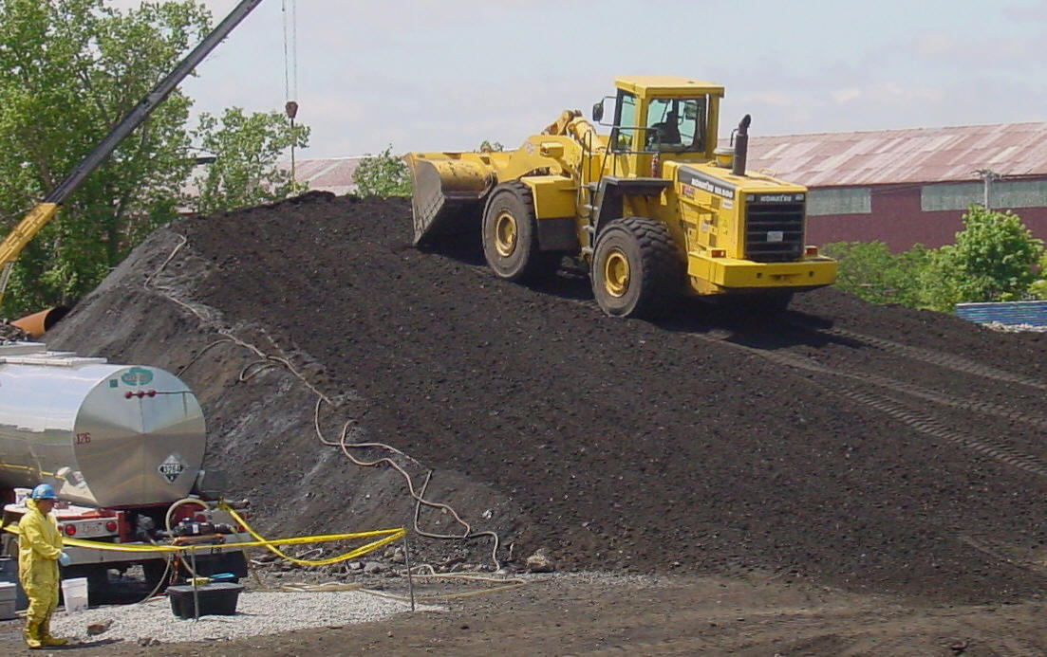
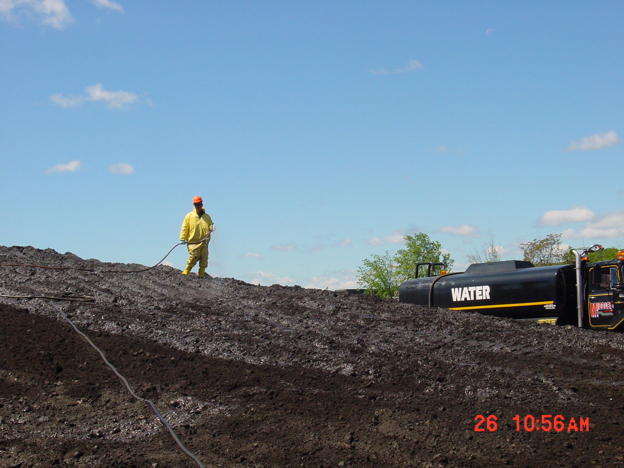

Figure 3 & 4 - Stockpile Treatment

In summary, the FESI-BOND® WET technology can be employed in a variety of methods, each designed to meet specific site requirements. The process is so flexible that different methods can be used across the same site as the excavation depths, loadout rates, and stockpile location availability changes.

