Diwo Decision
Intelligence Platform

Technical White Paper

Contents

The Last Mile of Analytics 3
Full Value from Analytics 3
360-Degree Decisioning 3
Diwo Architecture 4
Decision-Centric Architecture 4
Diwo Adaptation Studio 5
Business Context Graph 5
Data Ingestion and Management 6
Diwo DECIDE: Opportunity Management 6
Diwo Model Server 7
Diwo ASK: Guided Conversations 7
Scalability and Enterprise Readiness 7
Continuous Innovation 8
Summary 8

- The Last Mile of Analytics

The Last Mile of Analytics:

Is a manual and labor-intensive process. It relies on teams of analysts to manually synthesize historical and predictive insights, analyze root-cause, quantify impact and ultimately contextualize the optimal results for business consumption. Not only is this process complex and time-consuming, the manual nature limits scalability and introduces subjectivity and bias depending on the experience and judgment of individual analysts.
The last couple of decades have witnessed an explosion of analytic tools and technologies in every enterprise, regardless of the industry they serve. Enterprises have made massive investments in BI and visualization tools, data lakes and machine learning platforms to support data-driven decision-making. This has fueled the growth of analytic tools and technologies designed to deliver more insights, even faster than before.

But while the production of analytics has exploded, making a deluge of insights available to decision-makers, their ability to decide and act on these insights is still very limited. The reason for this is simple: the last mile of analytics – the process of translating insights from a variety of sources into managerial decisions – has remained unchanged throughout. The last mile results in managerial decisions that are untimely and sub-optimal, decimating the value created by modern AI and machine learning tools. At the same time, business managers have reached a point of analytic fatigue and are seeking a new way to make data-driven decisions.

  - Full Value from Analytics
At Diwo, we believe the full value from analytics can only be achieved through successful consumption of analytics and its application to business decisions. Diwo’s Decision Intelligence platform automates the last mile of analytics and closes the gap between insights and actions. Diwo combines prescriptive and descriptive analytics to give managers a 360-degree view of the information they need to make the best decisions, dramatically faster than traditional BI and visualization tools.

Diwo delivers a unique decisioning experience to business managers and executives, designed to reduce their cognitive burden and simplify decision-making. The system is architected to deeply understand business processes and uses the knowledge to ensure every interaction with users is highly contextualized. Along with surfacing precise insights, Diwo leverages AI to identify business opportunities and risks in a timely manner and recommend the next best action to decision-makers. Diwo’s natural language interface and tailored graphical interface simplify access to even the most complex analyses and machine learning models. It constantly learns from interactions, decisions and data feeds to predict user actions and tailor insights and recommendations, further reducing the cognitive load on users.

The automation and configurability built into Diwo allow new decisioning applications to be deployed in a matter of weeks, 3-5X faster than alternative technologies. The rest of the document explains how Diwo’s innovative architecture brings these capabilities to life.

  - 360-Degree Decisioning
Diwo’s platform features two modules – DECIDE and ASK, through which it delivers precise analytic insights and recommendations at the right time to accelerate decision-making.
- DECIDE is the unique, prescriptive capability. Diwo’s DECIDE module continuously senses potential business risks and opportunities as new data is ingested into the system. It quantifies the impact to the business and recommends the best strategy to address the situation in a timely manner. DECIDE ultimately gives users control, allowing them to evaluate alternate strategies and understand the impact of their decisions a priori.

- The ASK module cuts through the analytic clutter that business users face every day. ASK offers a guided conversational interface that understands users’ context and intent, and directs them to the most relevant insights and recommendations. It anticipates needs based on users' context, performs causal inference and accelerates analytic decision-making.

- Diwo Architecture
Diwo’s Decision Intelligence platform has been designed from the ground up to automate the last mile of analytics and transform decision-making. It is an intelligent and highly adaptive system that works to continuously optimize the business. The patented architecture brings together the latest in AI, machine learning, statistical inferencing, NLP and distributed data management to deliver on competing dimensions that are seemingly unattainable in a single system:

- Deep personalization through understanding of the business context
- Real-time analytic response across massive data volumes
- Ease of setup and configurability to support business agility
- Fast time to value through rapid application deployment

  - Decision-Centric Architecture
Traditional analytic tools and platforms typically operate within a single layer of the analytic stack – whether data management, insight generation or visualization. Integrating these layers to deliver the right insights, while preserving the meaning and appropriate use of the data, is time consuming and error prone. More importantly though, this data-centric approach results in insights getting fragmented across a variety of different reports, dashboards and visualizations, resulting in decision latency.

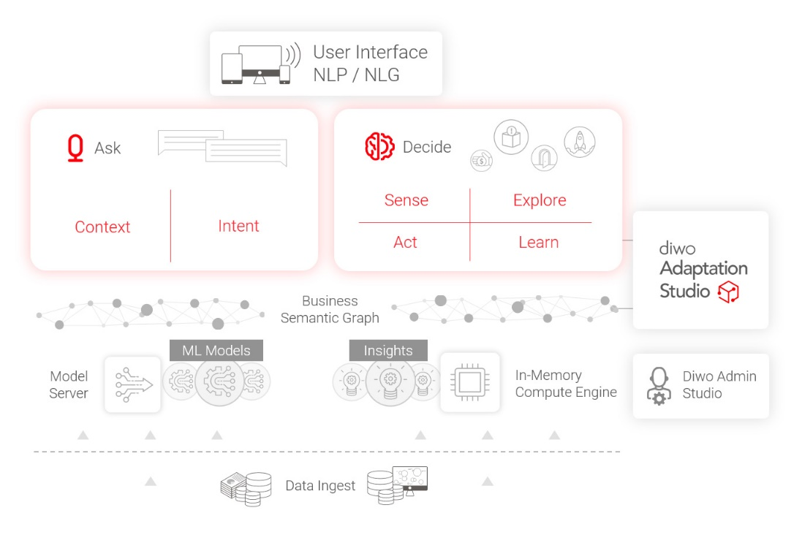
Diwo integrates the key layers of the analytic stack into a single architecture, resulting in faster deployment, rapid change management and automation of a more streamlined analytics process. Diwo's decision-centric approach requires organizations to start with the decisions they need to make and work back to the models, data sources and computes necessary to support decision-making. The integrated architecture allows data from input sources, user interactions and decisions to be used throughout to learn and adapt the system to different users and organizations.
Figure 1 Diwo Architecture Components

  - Diwo Adaptation Studio
The Diwo Adaptation Studio is the gateway to configure and customize the platform to a client’s needs, while accelerating time to value. It enables clients, partners, developers and subject matter experts to embed context, map data elements, set up Opportunities and customize the user interface, all from one place. The business requirements, business and data definitions, KPIs, metrics and configuration parameters associated with a business process are fed into the Adaptation Studio through simple, formal English captured in the Confluence™ collaboration tool.

Diwo is an enterprise-class platform and allows organizations to customize it’s look and feel, aesthetics and brand identity to their organization’s specifications. The Diwo Adaptation Studio provides the ability to customize the UI, including colors, themes, iconography, images and visuals.

  - Business Context Graph
Diwo’s Business Context Graph (BCG) is the system’s brain. It captures and represents domain knowledge, user context and configuration parameters for use by all components of the system. BCG plays a critical role in providing a highly personalized experience to users, rapidly guiding them to actionable recommendations and insights. It also automates the insight generation and ranking process within Diwo to improve operational efficiency, scale and speed to market.

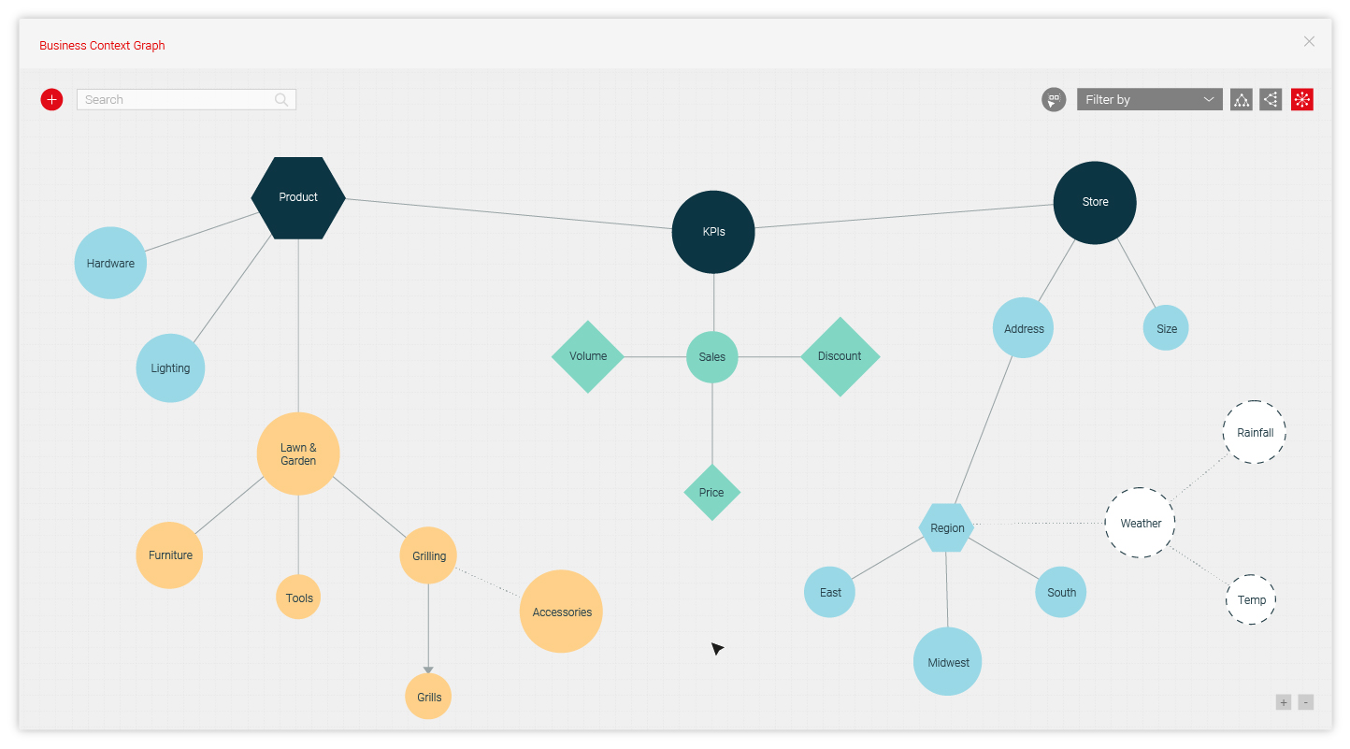

BCG is a dynamic probabilistic graph that is automatically generated from business requirements, historical data and predictive insights. It continually evaluates relationships between entities and Key Performance Indicators (KPIs), discovers new relationships and trends, and performs anomaly detection and time series forecasting as new data is ingested into the system.

BCG leverages customized probabilistic graphical models such as Bayesian Networks and Markov models to evaluate conditional probability or strength of multi-level relationships. It can process either transactional or aggregated data to learn the structure of the graph for evaluating the relevance of different insights. BCG auto-generates insights based on a variety of factors such as time, context and material impact.

  - Data Ingestion and Management
One of Diwo’s key strengths is its ability to break down decision silos in organizations by letting users draw upon data from a variety of different subject areas for decisioning. Diwo supports a broad spectrum of sources to ingest data from, covering all key warehouse and operational systems across industries. It automatically generates the data schema from business requirements to load data into the system. Data is ingested and stored in a distributed in-memory database, which allows for fast computations and aggregations.

The system intelligently creates and manages multi-dimensional aggregates, called cuboids, to deliver real-time user responses across petabytes of data. The integrated architecture allows Diwo to learn from user queries and interactions, and manage the creation and lifecycle of the most appropriate cuboids from a possible combinatorial number. It also computes predictions, KPIs and metrics as new data is ingested into the system to keep insights refreshed.

  - Diwo DECIDE: Opportunity Management
Diwo empowers users to make better decisions faster as they encounter uncertain and dynamic situations. Diwo represents business decisions in the form of “Opportunities”, which are then surfaced up as recommendations in the DECIDE module. An Opportunity in Diwo is a time-sensitive business situation, which, if not addressed, will likely have an adverse impact on the financial performance of the business, either due to a missed potential gain or avoidable loss incurred.

Diwo formalizes the decision-making process within Opportunities, which are templatized workflows based on a patented decision-making framework called SEAL™ (an acronym for Sense, Explore, Act, and Learn). Diwo Opportunities are designed to:

- Reduce cognitive load on decision makers
- Analyze situations at a much finer granularity to continually optimize the business
- Include objective evidence and quantification in decision-making
- Facilitate timely decision-making by predicting business situations well in advance
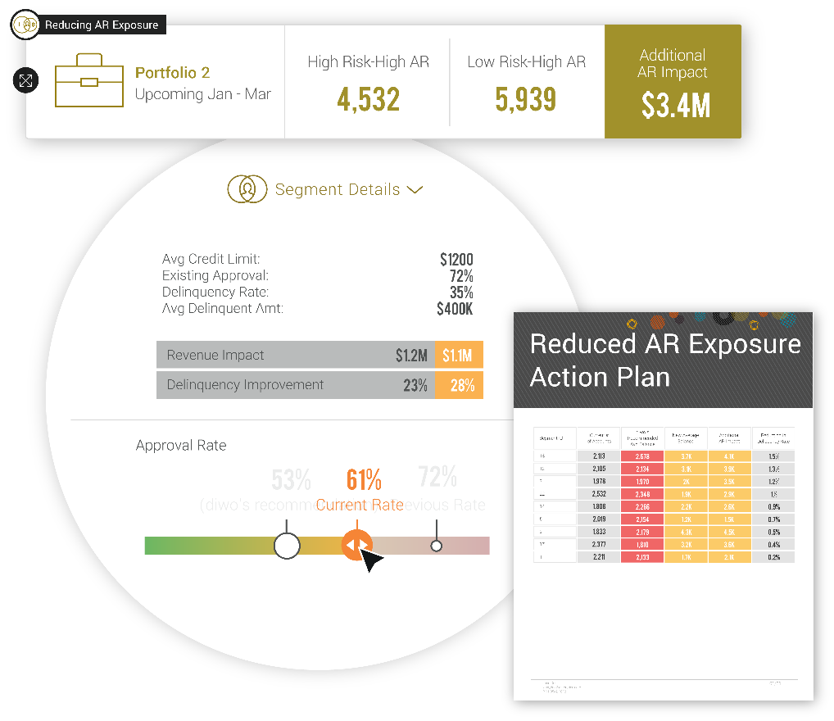

Within each Opportunity, Diwo continuously analyzes incoming data streams from various sources, sensing business anomalies and trends. It explains the potential impact of material Opportunities, while recommending an optimized strategy to address the business situation. Diwo ultimately puts the control with decision-makers, giving them the tools to explore alternative strategies by tweaking appropriate decision levers. Once a strategy is approved, Diwo formalizes the tasks that should be carried out to implement the strategy and passes them on to a downstream workflow or operational system. Continuous learning in Diwo allows the system to dynamically adapt to user interactions, new data and events on the platform and improve the recommendations it delivers to decision-makers.

Opportunities are set up and customized in the Adaptation Studio by simply mapping appropriate elements of the Business Context Graph and connecting appropriate Machine Learning models to the opportunity template. The Diwo system takes care of the rest, including generating the schema, setting up pipelines for sensing opportunities and scheduling jobs for timely execution.

  - Diwo Model Server
The Diwo Model Server provides a centralized, scalable infrastructure for deploying and executing Machine Learning models within the platform. It integrates model predictions with the Diwo platform in a seamless manner, enabling faster deployment, execution, and management. The Model Server can integrate ML models from a variety of sources such as R, Python, or AutoML tools.

Once a model is developed and ready for deployment, the Model Server loads its artifacts into a database and fetches associated metadata that is required to deploy the chosen model. The Diwo Adaptation Studio maps the model to an Opportunity and generates the (Sense) pipelines for executing the model. The Opportunity dictates the frequency or trigger for executing the model, based on which model is executed by calling its APIs with the requisite features and inputs.

As an example, the Sense pipeline of an Inventory Management opportunity may execute a time-series neural network model on a weekly basis to forecast demand for a product, and then compare it with planned quantities to identify shortages or surpluses.

  - Diwo ASK: Guided Conversations
In contrast to simply answering questions posed by users, Diwo applies AI to guide them to the most relevant insights and recommendations based on their context. Diwo derives user intent and context from the BCG, prior interactions with the system and access rights granted to the user. As Diwo traverses the BCG, it considers the relative weights of the links between nodes to perform causal inference, identify and rank insights, and determine related topics.

The auto-context generation and evolution of BCG, combined with graph mining, make the ASK module highly scalable as new subject areas are introduced and insights generated. The natural language interface hides the complexity of the system from the user, while multi-modal responses via voice, generated text and interactive visuals reduce the cognitive burden for users – making it easier for them to evaluate options, make a decision and add value to the business

Diwo continuously learns from user interactions, preferences and intent to better contextualize and personalize the overall decisioning experience. It builds the user context from previously asked questions, time of the day/week, recommendations and auto-context insights generated from BCG, to predict the next set of possible questions and enhance the conversational AI capabilities.

  - Scalability and Enterprise Readiness
Diwo is built on a modern, cloud-agnostic architecture that is highly scalable and enterprise-ready. The Diwo architecture is a collection of microservices, organized under specific functional modules to improve modularity and resilience to architectural erosion. Each microservice is distributed, containerized and stateless, and communicates with others via asynchronous messaging.

The entire system is very easy to deploy and manage through the Diwo Administration Studio. All system related configurations such as connectivity, platform configuration for high availability and scalability of clusters to meet Service Level Objectives for a deployment are set up and managed from the Admin Studio. Diwo continually monitors health metrics, error logs, usage patterns, and associated impact to business KPIs and proactively alerts administrators.

User authentication and access control mechanisms are built into the core platform. The system integrates with 3rd-party security authentication tools such as Ping Identity or Single Sign-On authentication mechanisms such as LDAP and Active Directory, for enterprise-grade data security and access control.

- Continuous Innovation
The need to make better decisions faster and more frequently is a reality that every organization is facing, regardless of the industry they operate in. At the same time, AI and analytic technologies are evolving at a very rapid pace, forcing organizations to keep up or risk being left behind in their markets. Diwo helps organizations achieve these objectives by continually innovating and incorporating new developments in AI and ML, while simultaneously simplifying a user’s ability to consume and utilize analytics in the business moment when action is required.

The new capabilities on the roadmap include a mobile interface, which will give users easier access to important insights and recommendations, wherever they need them. The CXO interface will aggregate decisions associated with a process to give executives a consolidated view of the decisions impacting their business. Additionally Diwo WATCH will provide decision-makers with the ability to continuously sense trends in the data via a simple UI that delivers a real-time overview of their business

- Summary
Businesses today need an analytics platform that facilitates decision-making and empowers users to drive real-time decisions and action. Diwo delivers a Decision Intelligence platform that allows users to seamlessly go from seeing changes in the business, to deciding what to do about it and taking corrective action in seconds.

Diwo is designed to understand the business context and automatically synthesize insights from a variety of sources. The integrated architecture allows Diwo to optimize all layers of the analytic stack to help maximize the impact of business decisions. More importantly, it allows every service within Diwo to continuously learn from user interactions, historical data and decisions made, to deliver a more personalized and precise decisioning experience. Diwo presents a simple and highly intuitive interface to end users, masking the complexity of the underlying architecture.

The Diwo architecture is enterprise-ready, with built-in capabilities for user security, system setup and administration. The configurability of the platform means a system that is not only 3-5X faster to setup, but easy to evolve as the needs of the business change.

Diwo delivers a modern and transformative approach to analytics and decision-making. As your business changes, Diwo adapts and surfaces actionable insights and recommendations - driving agility into your decision-making process. Diwo is the modern way to empower decision-makers to act faster and stay ahead of the competition. To learn more, visit www.diwo.ai.
11/2021 – Proprietary and Confidential – Diwo, LLC 8

