Trusted Family Introduction Email
Subject: Welcome to the Insert Corporation Network at Trusted Family

Dear Insert audience group,

We will be launching the insert corporation or family name portal, for family members, trustees and advisors in insert launch date. insert corporation or family members staff & other insert applicable groups are already active users of this as part of our internal communication process.

Our plan is to launch in two phases. The first phase will be to “onboard” members of the insert name of board Board of Directors and related committees, given that we have upcoming meetings in insert meeting date. The second will onboard all other family members and advisors (if applicable).

You will receive a registration email from do-not-reply@reply.beclose.net, containing the graphic: Screenshot Invitation YOUR email. (Found under Admin> Network Administration> Email Templates)

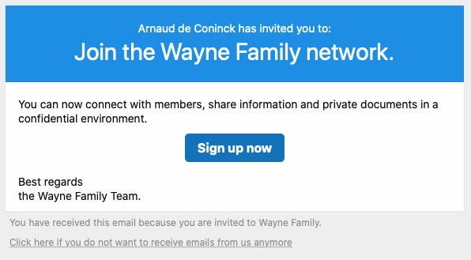

Please check you Spam or junk folder if you do not receive the invitation e-mail in your in-box on insert date of invitations.

When you click “Sign up now”, it will bring you to the portal and prompt you to create a password as well as add generic bio information. After the information is entered you will be a registered member. Once you access the portal for the first time, make sure to bookmark the address: https://YOURDOMAIN.trustedfamily.net for easy access in the future!

The insert network name is mobile friendly, so we encourage you to download the Trusted Family mobile application. We will be offering a demo of insert network name on Insert demo date – feel free to navigate around the portal prior to the demo.

We are excited to be launching this initiative and know the portal will be an effective way to share information and materials, facilitate the management of meetings and events, and elevate communication in a secure and efficient way.

