Start up SQL 2008 Management Studio on the SQL Server instances for the SafeCom Master Server

Locate the publication “sccoretrans”

Choose the “Replication” folder, and then the “Local Publications” folder.

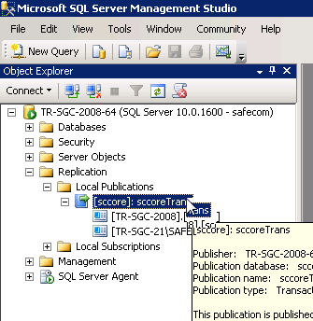

Right click on the “[sccore]: sccoreTrans” then choose “Properties”.

Choose the “Articles” icon.

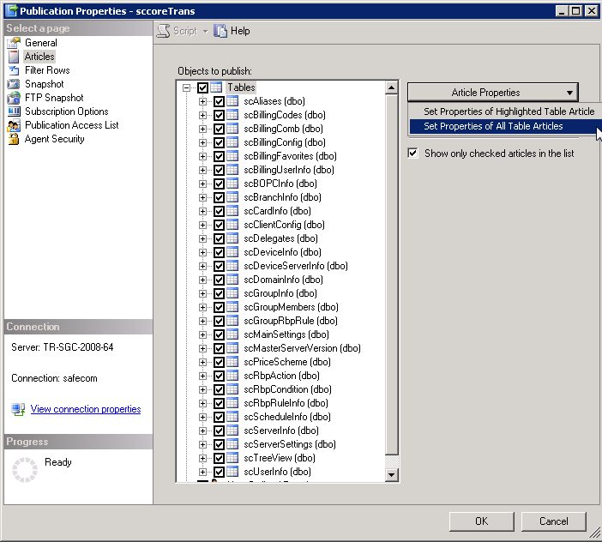

Click on the “Article Properties” icon and then choose “Set Properties of All Table Articles”.

Scroll to the top.

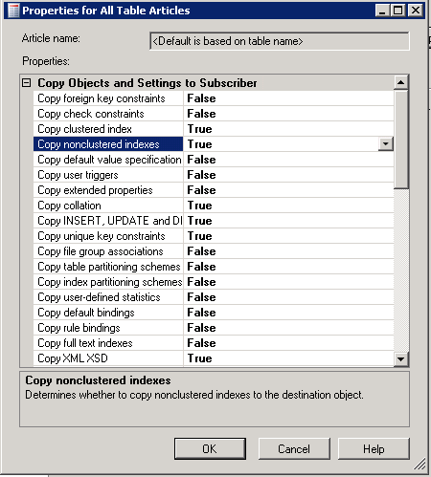

Make sure to set the “Copy clustered index” and “Copy nonclustered indexes” are set to “True”.  
Click “OK”, and “OK” again.

Then Reintialize all subscriptions by generating a new snapshot for each Slave Server.

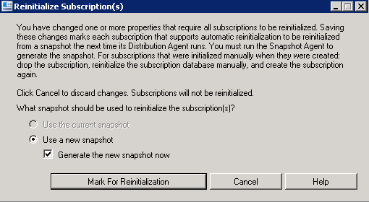

Then press the button “Mark for Reinitialization”.

Done.

Please remember to repeat the steps after adding a new slave server or after having done a “Repair Replicaton” in SafeCom Administrator.