With the SafeCom G3 440*03 a new feature called “Store Doc on first server” was introduced. This feature is default enabled on all following G3 and G4 version.

This feature in a multiserver environment ensures that even if a user has homeserver on a specific SafeCom server, e.g. slave2, and the user prints in via a printer share on another server e.g. slave1, then his job does not have to travel all the way over the network to his homeserver, but stays at the first SafeCom server it meets.  
So the user can have jobs spread all over all SafeCom servers in the multiserver environment.

Some customers has wanted to disable this feature, e.g. if they have all their SafeCom servers in a datacenter, and in order to do load balancing, wants users to only have print jobs residing on their designated homeservers.

This manual shows how to disable the Store Doc on first server.  
Please note: If you decide to disable Store Doc on first server, then you must disable the feature on ALL SafeCom servers at the same time. Either Store Doc on first server is enabled on all SafeCom servers, or disabled on all SafeCom servers. Remember that this also applies to future slave servers that are added at a later stage. (Best practice is to ensure correct Registry setting on the new server before adding it as a new slave server)

1. Stop the SafeCom service and print spooler service on the Master server. (this to avoid SafeCom failover to happen)
2. Stop SafeCom service and print spooler service on all slave servers.
3. For clustered SafeCom servers: Use the Cluster Administrator to take the SafeCom service and Print spooler service offline.
4. For each SafeCom servers: (If your server is a G4 server then in this section replace G3 with G4)
   1. Open Registry editor (regedit) as “Run as administrator”
   2. Browse to “HKEY_LOCAL_MACHINE\SOFTWARE\SafeCom\SafeComG3”  
      (If running SafeCom Server 32 bit version on a 64 bit OS, then instead browse to: HKEY_LOCAL_MACHINE\SOFTWARE\Wow6432Node\SafeCom\SafeComG3)  
      Create a DWORD key called SDFS with value of 0  
      (SDFS=Store Doc on First Server. Normally this is set to 1 = enabled  
      By setting the value to 0, the feature is disabled)  
      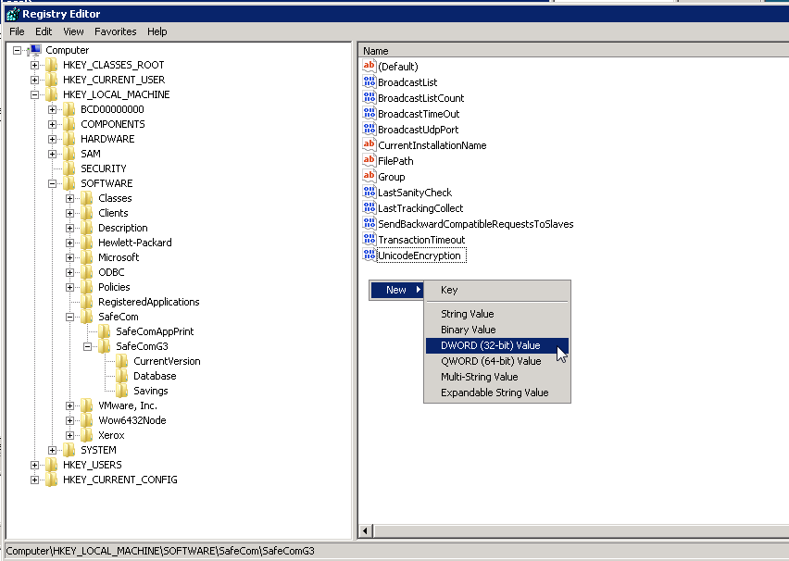

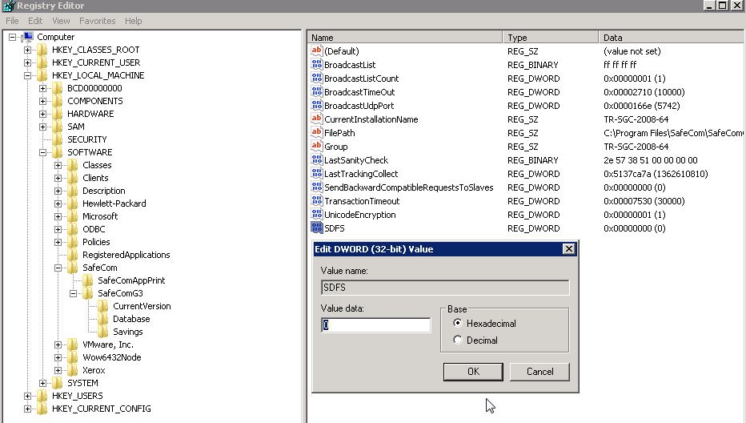

* 1. Press OK, and close Registry.

1. Do this for all SafeCom Servers as described above.
2. When done on all SafeCom Servers, then start print spooler service and SafeCom Service.
   1. If you want to avoid automatic SafeCom Failover to happen, you would want to start up the services on the master server after all slave servers has been made operative.
   2. For clustered SafeCom servers: Use the Cluster Administrator to take the SafeCom service and Print spooler service online.
3. Done.
4. Dispersed documents created prior to the registry change are not changed. They will remain on their respective SafeCom servers until deleted either by user or by the system.

Example of multiserver installation before and after applying the registry hack:  
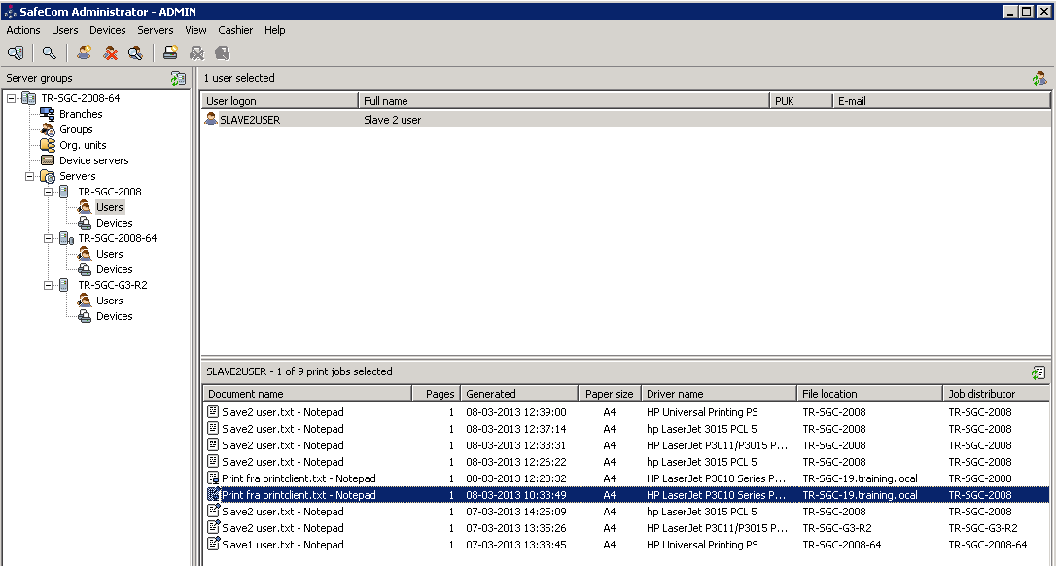  
Slave2 user has homeserver on server TR-SGC-2008.  
Jobs submitted via various printservers before March 8th at 12:15 was handled with Store Doc on first server being active, and jobs submitted after 12:15 was handled with Store Doc on first server being disabled.

As we can see, when the Store Doc on first server was disabled, all new jobs (except for print client jobs) were sent to the user’s homeserver. We can also see that the Print client is still working correctly, so that jobs are stored locally on the Print Client workstation, but users homeserver is notified (Filelocation=Printclient Workstation. Job distributor = users homeserver)

One last time:  
Please remember to always have the same SDFS value on all your SafeCom servers at the same time.  
If you need to change from Disable to Enable or vice versa, then please stop SafeCom service and Print spooler service on all servers (for clustered SafeCom servers take SafeCom service and Print spooler service offline). Then do the registry change. Then bring SafeCom service and print spooler service online (for clustered SafeCom servers take SafeCom service and Print spooler service online).  
To avoid funny situations with regards to SafeCom failover, then start taking the Master server offline as the first server, and bring the Master server online again as the last server.

When adding new slave servers, then please have the correct SDFS registry value set prior to adding the server as a slave server.