Memorialise

Introduction
CareApp is introducing a new feature to support the collection of memories that are stored inside CareApp for a resident or community member when they leave CareApp. We want a way that staff can bring together those special moments when a resident passes away, by capturing and sharing with the family in a video format.

This process also supports the facility to archive the community in CareApp and support the family to transition out of CareApp sensitively.

How does it work?
Memorialise works for administrator roles only. CareApp allows them to create and share a slideshow featuring residents' best moments. This function will also support the staff to archive the resident inside CareApp and provide a more sensitive and thoughtful approach to finalising the family's journey with CareApp.

Providing Feedback
We want to hear from you about your experience with this feature. This will help us improve the feature and make a more useful tool for you. Please get in touch with us by emailing support@careapp.com.au with any questions or feedback you may have.

Using this feature
Organisation administrators have the permissions to conduct this feature. This feature needs to be performed on the desktop version of CareApp.

From The Community Page (via desktop)
Select the community resident you want to use the memorialise feature for. This will occur when you have a resident pass away and you want to prepare a thoughtful collection of memories for their family. To navigate to this feature when in a community profile, select the edit button on the top right.

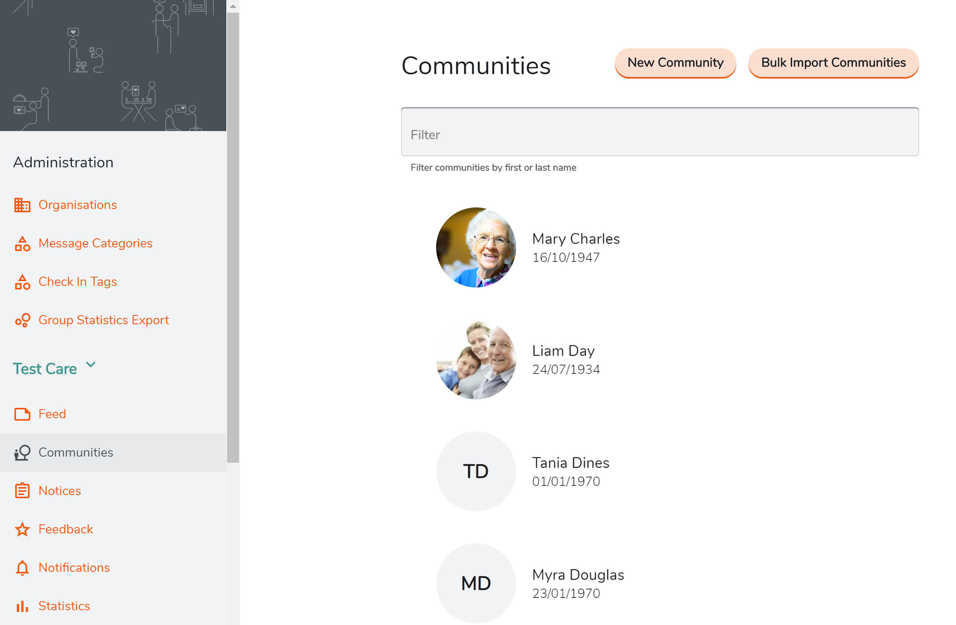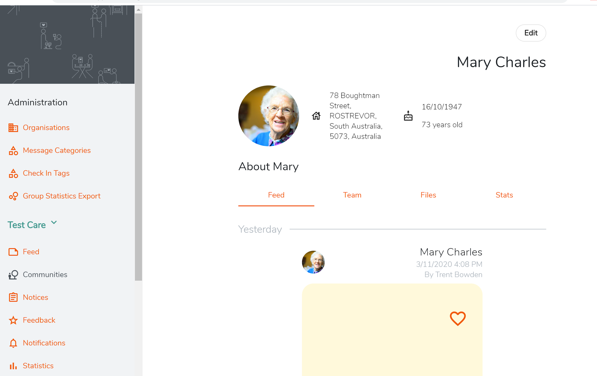

Click on the setting tabs for the community resident and this will reveal the capacity to archive and memorialise this community/resident.

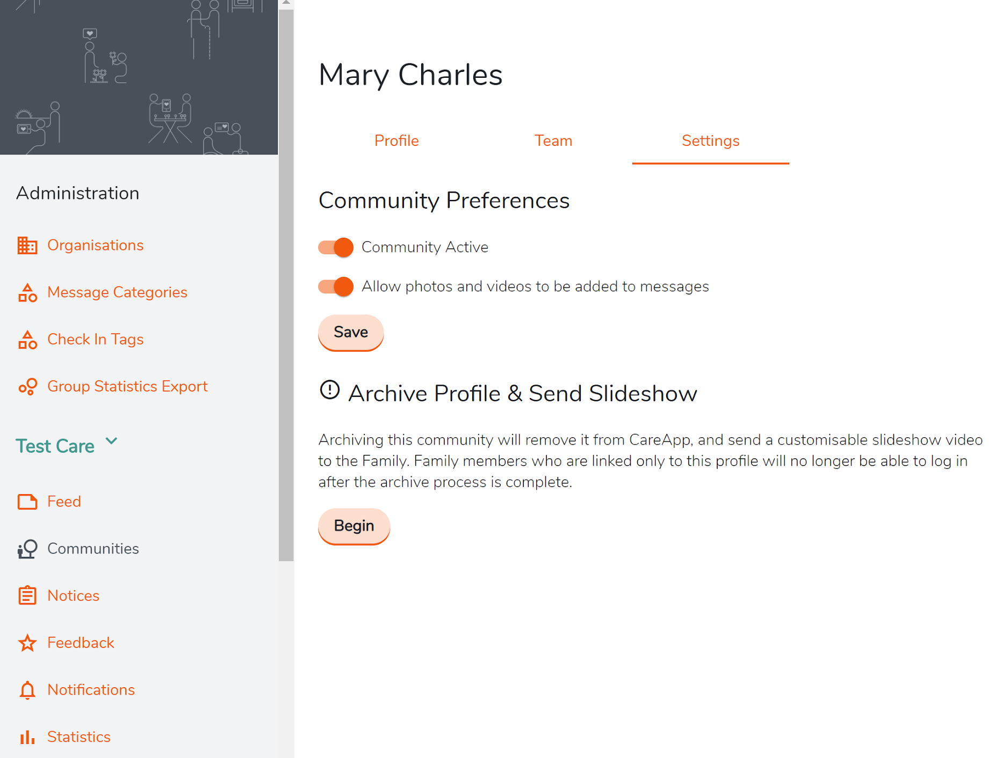

Begin
When you start this process you will move to a screen that will describe this process and allow you to select the images (up to 20) and edit the title and ending remarks if you choose.

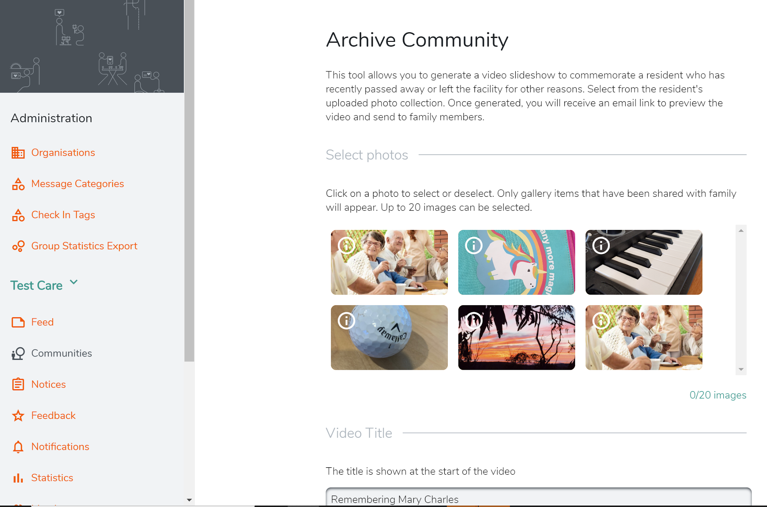
Before you generate the video, you can choose to add music. Once ready select generate preview.
A generating preview screen will appear and while this is loading you are able to leave this screen and an email will be sent when the preview is ready.

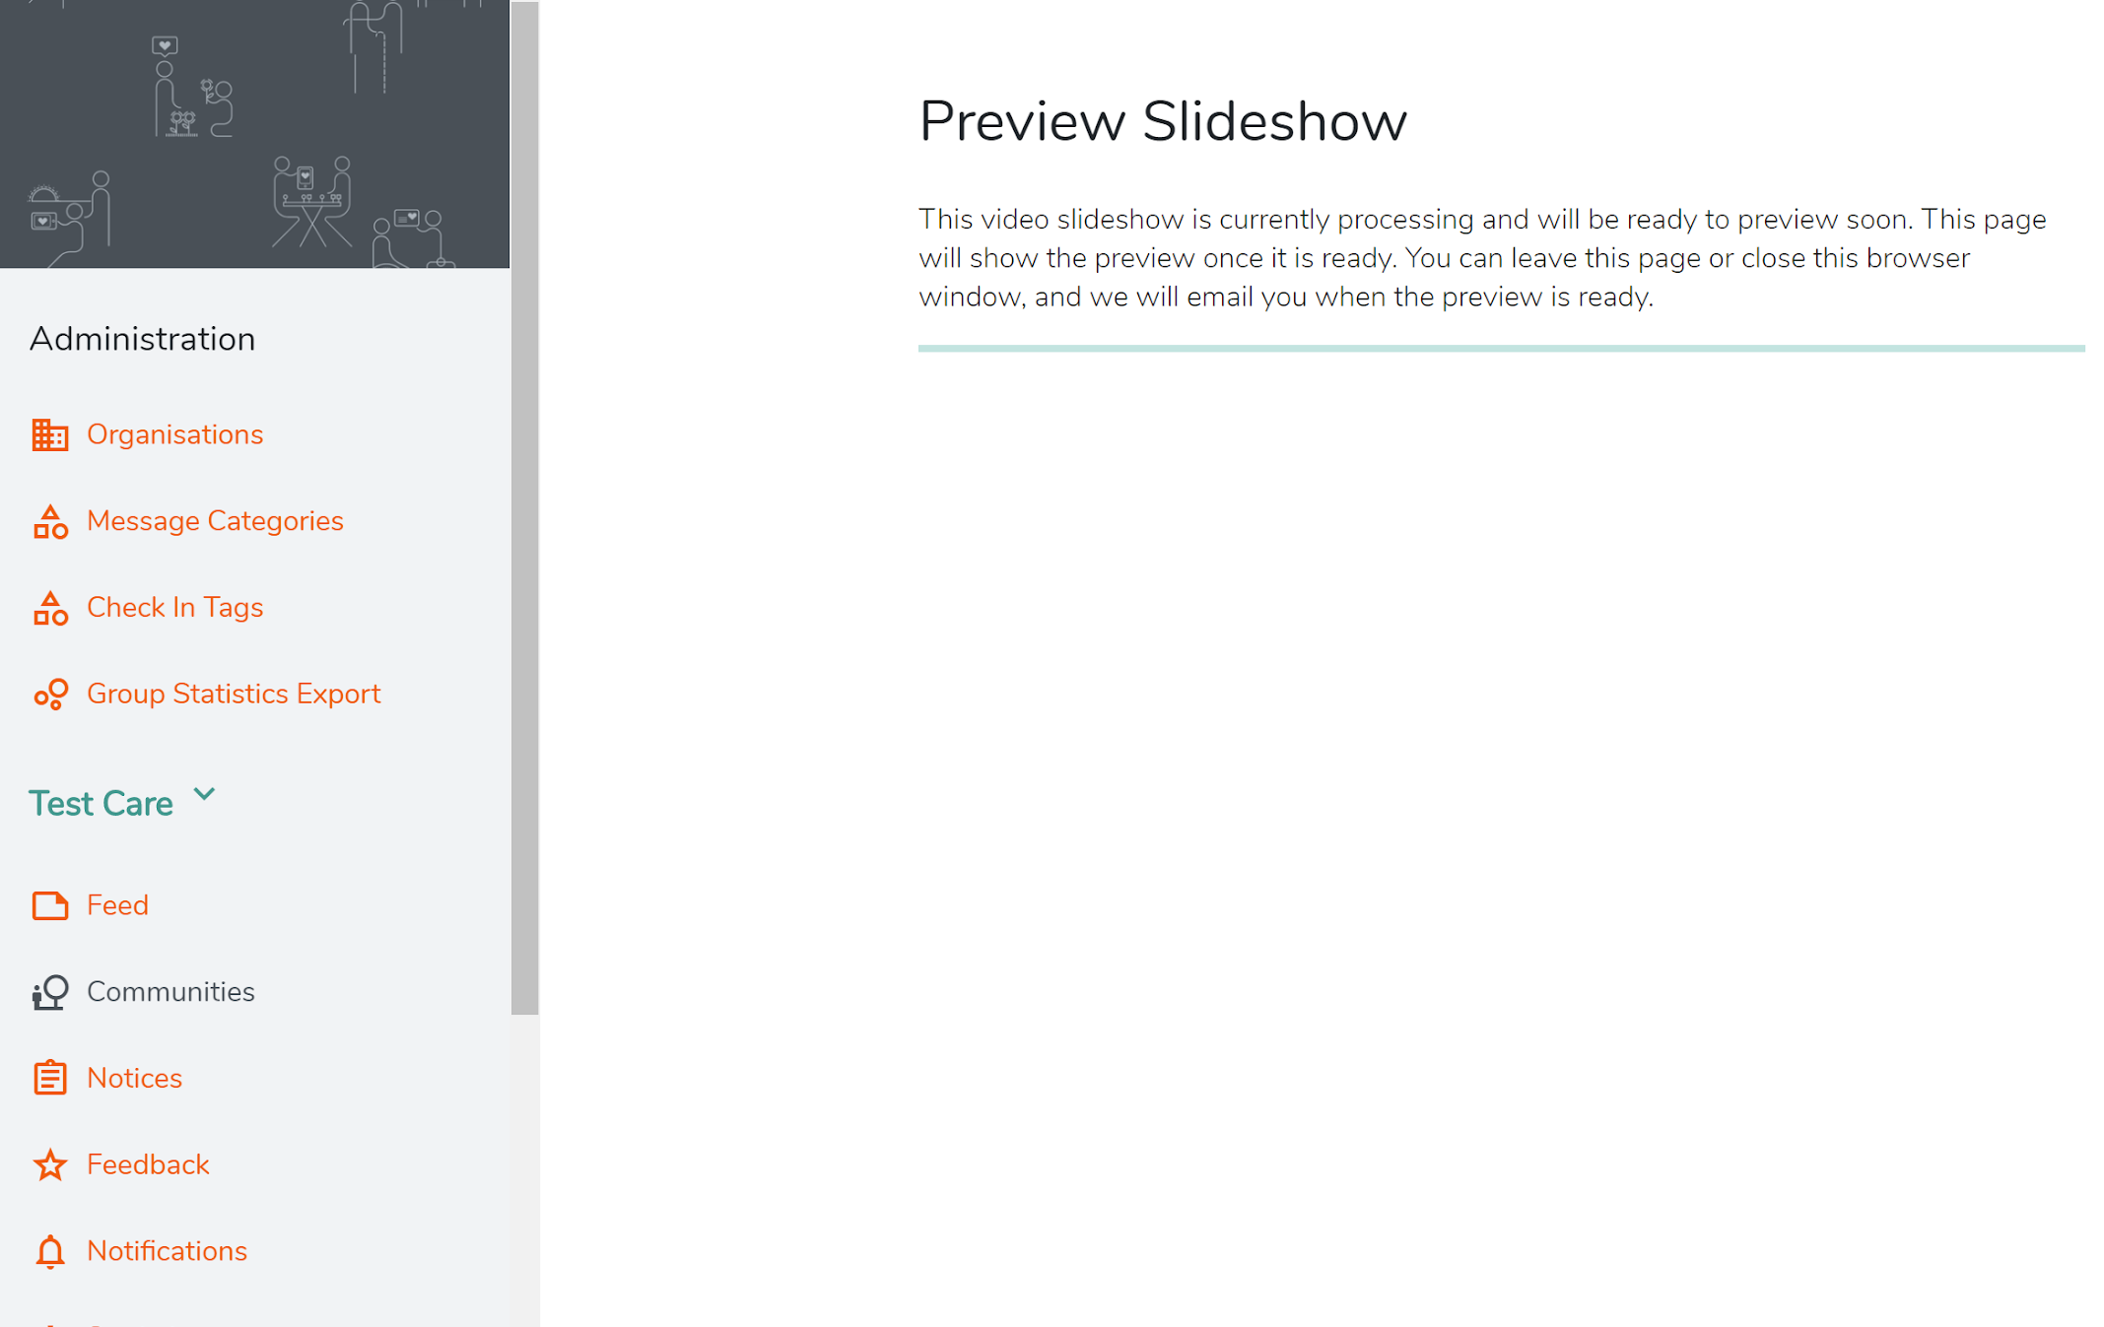

When the video preview is ready you will be sent an email and will have a chance to view prior to saving.

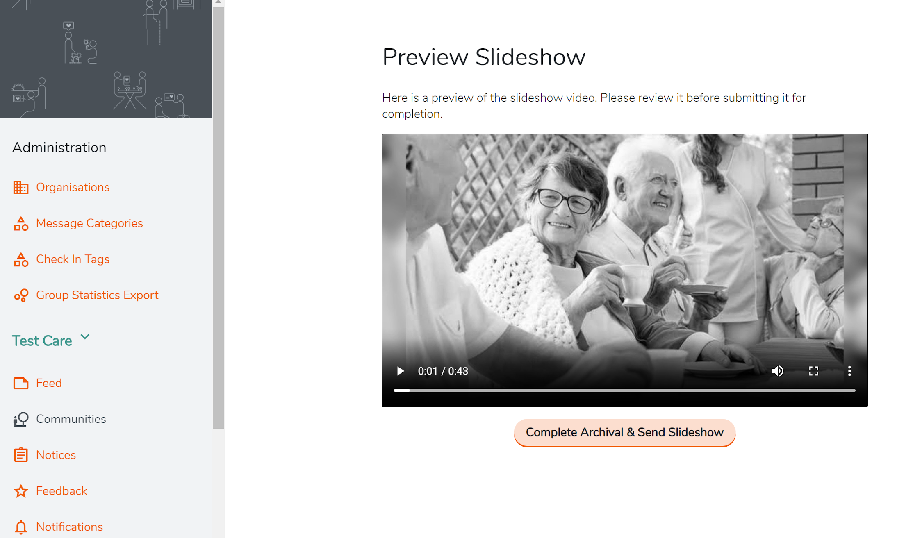

Completing action
To complete this task and to remind you that this will deactivate the resident’s account which will deactivate family who have no other non-archived residents and send a link to download the video.

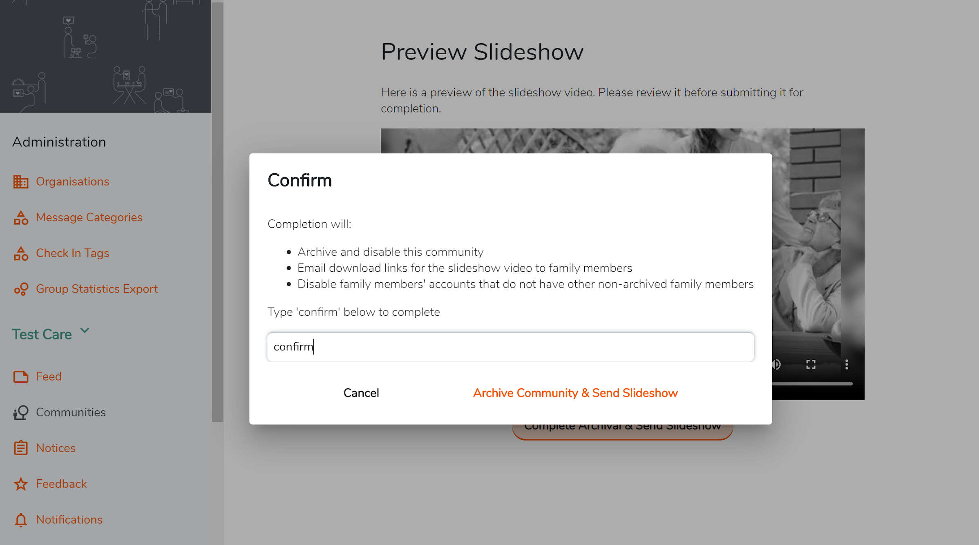

Congratulations you have created a lasting memory for family and friends during a difficult time.
Discard Slideshow

If you need to cancel this action due to error, you can select the discard slideshow at the bottom left of the slideshow. A confirmation screen will then appear for you to confirm and discard.
