PTCOM Technology

ExoHome Wi-Fi HNA

Product Specification Sheet

Revision History
Date | Revision Content | Revised By | Version
2021/2/17 | Initial Draft | Jarron Cho | 0.1

Content

- Introduction 3
  - ID/PCBA 3
  - PCBA 3
- Hardware Specification 4
- Function Spec 5

- Introduction
This is a home network adaptor (HNA) with low power Wi-Fi technology which connects to ExoHome cloud. This HNA comply with TaiSEIA 101 protocol (CNS16014). Here is the user scenario.
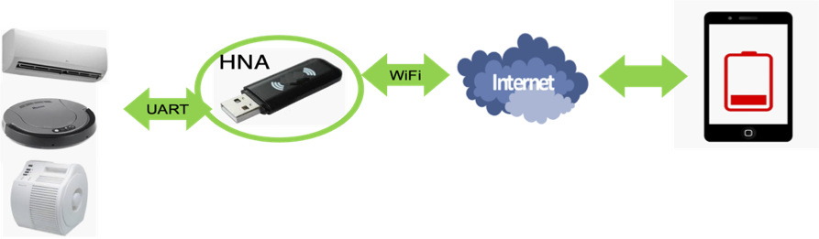

  - ID/PCBA
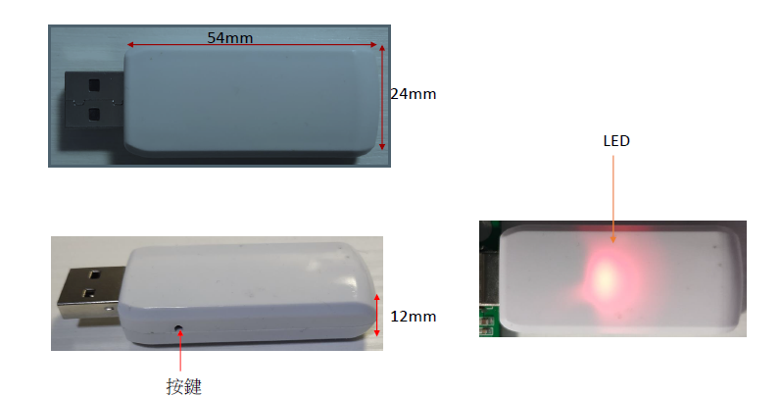
  - PCBA
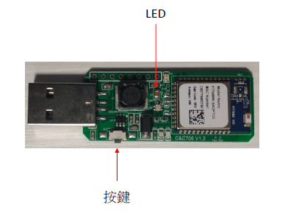
- Hardware Specification
Spec Item | Description
General
System | Wi-Fi 802.11 b/g/n
Reset Button | Long Push (3 seconds) to Factory Default
Green LED | Power LED
Tri-Color LED | RED: Setting mode, Blue: Pairing mode, Green: Normal mode
通訊端子 | 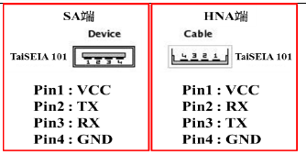
通訊介面 | UART, baud rate (9600~11200bps)
Wi-Fi
Wi-Fi Compliance | 2.4G 802.11 b/g/n, 1X1 Antenna
Wi-Fi Security | 802.11b/g/n Wireless with WEP/WPA/WPA2 security
Antenna | Hidden Antenna
Power
Power Input | 5V-12V input
Power consumption | Less than 0.5W (TBD)
Others
Operation Temp | Operating Temp: -20°C to 50 °C
Storage Temp | Storage Temp: -40°C to 70°C
Dimensions (W x D x H) | 54 mm X 72 mm X 12 mm
Certifications | FCC 15B (TBD), NCC

- Function Spec
Spec Item | Description
General
ExoHome cloud | Support
TaiSEIA 101 | Support
Factory Default | Yes
Firmware upgrade | Yes
App
Android App | Yes
iOS App | Yes
支援裝置
TaiSEIA Compliance Smart Appliances | 冷氣機、除濕機、電冰箱、洗衣機、乾衣機、熱泵熱水器、電視機、空氣清淨機、微波爐、電子鍋、開飲機、烘碗機、電 磁爐、全熱交換器、電扇、燃氣熱水器、燈具、居家顯示器、智慧電表閘道器及通用裝置。
支援功能
 | Please follow TaiSEIA 101

