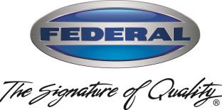
Doug Haworth Federal Industries
VP Sales & Marketing 215 Federal Ave,
Belleville, WI 53508

February 24, 2022
To: Federal Key Customers
RE: Stainless Steel
As you may be aware, stainless steel prices have more than doubled over the course of the COVID-19 pandemic. Federal has done everything we could to hold pricing down related to this optional material, but we can longer bear the burden of the additional costs. As a result, we will be increasing our pricing on all stainless-steel options by 80%, effective immediately. Historically, we have protected pricing for thirty days, however, due to the details previously noted, and since this is only affecting specific optional accessories, we will not be able to do so. We will honor all existing orders, however, any outstanding quotes that include stainless steel are void and a new request for quote will need to be submitted.
For any of you that do not follow the pricing of stainless-steel, a more simplistic view is to look at the price of Nickel, which is a major price driver in the cost of stainless-steel. Here is a snapshot of nickel prices from the start of the pandemic through today from the London Metal Exchange:
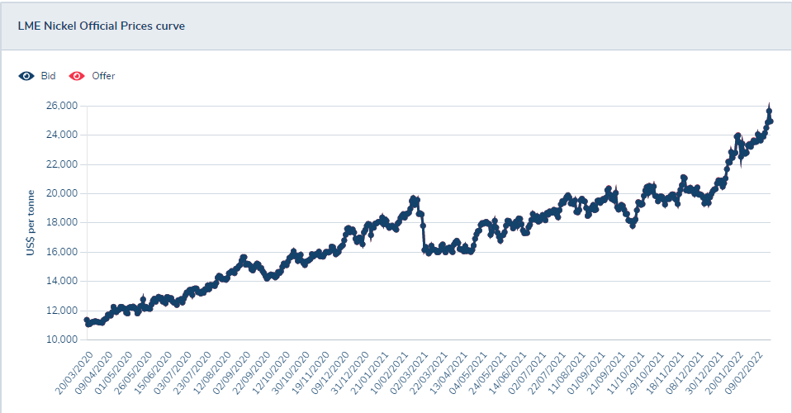
A list of the affected accessories with updated pricing is attached for your convenience. If you have any questions or concerns, please feel free to contact me or your regional Sales Director.
Sincerely,

Doug Haworth,
Doug Haworth
VP Sales & Marketing

