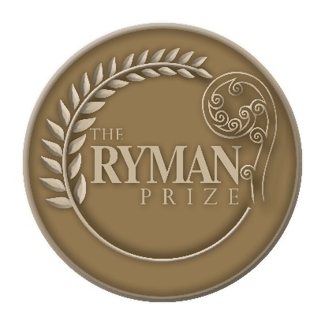
The Ryman Prize 2021
Application/nomination form

The Ryman Prize is open to anyone, anywhere in the world for work completed on an advance that has been proven to enhance quality of life for older people.
The prize could include, but is not limited to, a mechanical device, an invention, a discovery, a study, a book, an initiative, an invention, a proven idea, a completed research project or initiative or any other advance that enhances life for older people. The prize is to reward work done - not for speculative projects.

The award can be made to an individual or a team.

There are two methods of entry to the prize:

You can apply yourself (by filling in sections 1, 2, 5 and 6), or;

You can nominate someone else (by filling in sections 3, 4, 5 and 6).

The winning applicant (or winning organisation’s representative) will be flown to New Zealand to collect the prize in person. The prize ceremony is planned for October/November each year.

CLOSING DATE: 5pm Friday July 16, 2021. Scan and sign applications or nominations and send them to david.king@rymanhealthcare.com

SECTION 1: Applications:

I ………………………………………………………………………………………………………

(full name or names) wish to apply for the Ryman Prize

I………………………………..……………………………………………………………………...….

(full name or names) consent to the Ryman Foundation and its agents making enquiries, verifying

facts, carrying out research and obtaining information from others that it considers appropriate to

verify this application. All information will remain confidential.

Signature:

(NB: in the case of joint entries enter the name of all individual members as well as your main applicant’s name, the main applicant to be the chief point of contact)

Date:

Applicant’s details:

Name:

Contact address:

Email:

Contact phone number:

SECTION 2: Application statement (for applicants nominating themselves)

Please provide a statement of up to 1000 words on why you should be considered for the Ryman Prize

SECTION 3: Nominations

I ……………………………………………………………………………………………(full name)

wish to nominate

…………………………………………………………………………………….(full name of

Individual, individuals or organisation) for the Ryman Prize.

I………………………………..……………………………………………………………………...….

(full name or names) consent to the Ryman Foundation and its agents making enquiries, verifying

facts, carrying out research and obtaining information from others that it considers appropriate to

verify this application. All information will remain confidential.

Signature:

(NB: in the case of joint entries enter the name of all individual members as well as your main applicant’s name, the main applicant to be the chief point of contact)

Date:

Applicant’s details:

Name:

Contact address:

Email:

Contact phone number:

SECTION 4: Nomination statement (for applicants nominating someone else)

Please provide a statement of up to 1000 words on why the person or organisation you have nominated should be considered for the Ryman Prize.

SECTION 5: Referees

Please supply two independent referees who can verify your application or nomination. They must be comfortable with being contacted.

Referee 1:
Name:
Address:
Email:
Contact phone number:
Position/relevance:

Referee 2:
Name:
Address:
Email:
Contact phone number:
Position/relevance:

Section 6: Supporting documents

Please email any relevant documents or references to support your application or nomination. These could include publications, media coverage, or any other document that would be used to verify your application or nomination.

If documents cannot be emailed please post to:

David King
Corporate Affairs Manager
Ryman Healthcare
92 Russley Rd
Avonhead
PO Box 771
Christchurch 8042

