Adding the recommended footer to your document

Step 1: Set filename
Rename the filename of your document to be doc_doc number_doc name_version number
Example:

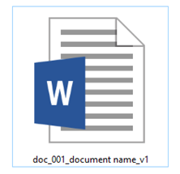

Document ID number (#)
The document ID# is system generated. To get the document number that LogiqcQMS will assign to the next document, go to the Document Register in LogiqcQMS and click ‘Add’. The ID# will be displayed. This number should be added to the filename of the document to ensure good document control when a document is printed out.

Step 2: Paste footer format into your document
Copy/paste the following footer format (between the red dashed lines) into the footer of your document:
---

doc_001_document name_v1 Page 1 of 4
© This document is the property of <your company name>
Once printed this document is considered an uncontrolled version. Refer to the LogiqcQMS for the current approved version.
---

Step 3: Update document name in your footer
Update the name of the document in your new footer by right-clicking on the doc name in the footer and selecting Update field:

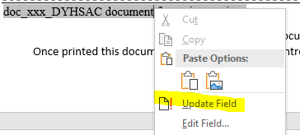

Notes:
- Initial version number
When uploading your document to LogiqcQMS for the first time, you will need to enter the current version number of the document. This number will be automatically incremented when new versions are approved and cannot be changed. The field only accepts a single numeral eg. 1

Add the footer style to your footer gallery in Microsoft Word

- Open this document in Microsoft Word.
- Select Insert/Footer/Edit footer
- Add your organisation name e.g. …the property of <organisation name>
- Highlight the entire footer, including the page number details on the right
- Select Insert/Footer/Save Selection to Footer Gallery. A dialogue box will appear:
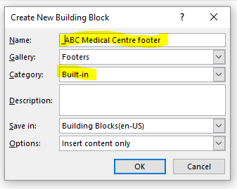
- Type a name for the footer style starting with an underscore eg. _ABC Medical Centre footer
- Change the Category from ‘General’ to ‘Built In’.
- Click OK.
- (Important) Close Microsoft Word completely. After saving any documents that may have been open, the dialog box below will appear. Select ‘Save’ to save the footer style for future use.

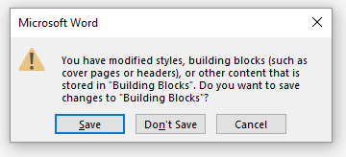

Your footer style can now be inserted to any Word document by selecting Insert/Footer and the selecting your footer.

