# Sofia Optimization

# Service Center Discovery Widget

| **Subject** | **Sample Screenshot** | **Discussion Topics with Your COL** | **Notes** |
| --- | --- | --- | --- |
| Client Announcement |  | What announcements do you want to push to your members?   1. Before and during AE (ex: Annual enrollment dates and key info – “Open enrollment is from September 21 – October 2, we are changing medical plans this year so you must take action this year”) 2. Just after AE (ex: ID card delivery timing) 3. After AE Q4 (ex: year-end reminders for FSAs, PTO balances) 4. Q1 (ex: wellness program, tax forms) |  |
| Username and Password Issues | No Single-Sign On (SSO):    Single-Sign On: | Important for the phones, especially for single-sign on (SSO) clients.  If no SSO: Pulls from Company Information  If SSO: What are the instructions for logging in through SSO? |  |
| Employee Demographics |  | Where do employees go to update their demographic information if it is wrong? |  |
| Medical/Dental/ Vision ID Card | **Yes response:**    **No response:** | Will there be an ID card for medical, dental and vision?  If no, what are the instructions Sofia should give members to help them use their benefits?  **Coming soon:** Vendor website information will be included in this response so remember to work with your COL on providing the right vendor websites. |  |
| EAP Information |  | Provide instructions (e.g., phone number/website and access code, if applicable) to access EAP resources |  |
| Tobacco Surcharge |  | If tobacco surcharge applies, insert details highlighted.  If the process to remove the surcharge is different during AE (e.g., remove through the enrollment flow) vs. after AE (e.g., need to complete a tobacco cessation program) – provide your COL with the details and timing to update it. |  |
| Spousal Surcharge |  | If a spouse surcharge applies, insert details highlighted. |  |
| EOI process |  | Enter details related to EOI process, if applicable. |  |
| Appeals | Response if appeal is NOT available:    Response if appeal is available: | If you offer an appeal – what is the process to submit it? |  |
| LOA process |  | What steps should members follow to request a leave of absence? |  |
| W2 process |  | Who do members contact if they have W2 questions. |  |

Plan/Vendor Set-up Reminders

Sofia pulls plan and vendor details into many of her responses:

* Work with your client services team to ensure your plan and vendor details are update with the correct information.
* For plan information – make sure the member-facing plan names (i.e., subgroups) are intuitive to the member (e.g., avoid general terms like “voluntary benefits” and provide more specific descriptions like “critical illness and hospital indemnity”) – this will be important for this annual enrollment as Sofia will be able to pull more plan information.
* For vendor information – provide your team the correct phone numbers and websites – this will be important for this annual enrollment as Sofia will be able to pull more vendor details into more of her responses.
* Remember! Don’t update the information yourself. Work with your client services team because changes can have a downstream impact to your carrier files.

Decision Support Tool Reminders

Sofia pulls leverages information in the Decision Support tools when members have specific information about what their plan covers.

* Work with your client services team to ensure the plan information is updated for medical, dental and vision even if you don’t use the MyChoice Decision Support Recommendation Engine.
  + If there are plan changes to the plans (e.g., deductible, coinsurance), these should be communicated to your team to update
* Below are some examples of current system fields Sofia pulls for medical:
  + Deductible
  + Out-of-Pocket Limit
  + Co-insurance
  + Copayment
  + Primary Care Visit
  + Specialist
  + Preventive care
  + Emergency Room
  + Urgent Care
  + Generic Drugs
  + Preferred Brand Drugs
  + Non-preferred Brand Drugs
  + Specialty Drugs
* Sofia can only pull information from system (default) fields and cannot yet pull in client custom fields. If you have any custom fields in decision support tool that is duplicative of system level and you want Sofia to pull this information, please work with your client teams to use an existing system field.
* Coming Soon – We will be adding more system fields for other plans

REFERENCE CENTER Reminders

Sofia refers members to find additional resources. Her search capabilities also will look for and present content directly from Reference Center:

* Remove or make “inactive” any documents that no longer apply
* Ensure the right structure groups are linked to the right documents
* When documents are loaded – ensure both the display name AND file name are intuitive to the member

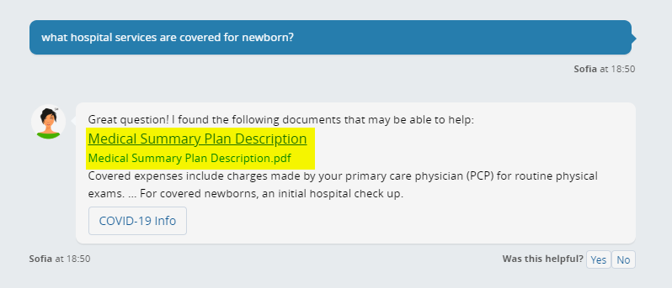

dependent and event verification reminders

On both Dependent and Event verification tabs in Verification Manager, ensure the custom translations are intuitive to members. This is what Sofia pulls in her responses when members ask about what forms are needed for verification and what is pulled into Initial Letter communications sent to members.

