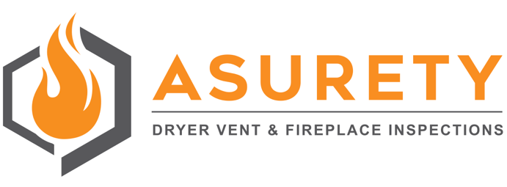

Tips for wood burning fireplace usage.

- Have your fireplace inspected and cleaned annually to ensure they are functioning safely and efficiently.
- Be sure smoke and carbon monoxide alarms are in working order.
- Keep an operational fire extinguisher in a location near the fireplace, which is easy to access.
- Keep combustible materials like carpets, drapes, decorations and furniture away from the fireplace when a fire is burning. A guard in front of the fireplace will help keep children and pets from harm.
- To ensure proper ventilation, make sure the damper is open before lighting your fire.
- Always use fireplace tools, not your hands, for handling burning logs.
- Do not use a fireplace as a furnace. A fireplace should be used for no more than five hours at a time.
- When starting a fire only use a match or commercial firelighter. Never use flammable liquids to start an indoor fire.
- Metal mesh screens should remain closed whenever your fireplace is in use to help keep embers in the fireplace.
- Burn only seasoned wood. The seasoned wood should have been cut and dried under cover for at least 6-12 months. Wet wood can increase creosote buildup, which can lead to chimney fires.
- Never burn plastic because it can release toxic chemicals and cause damage to your chimney, fireplace or wood stove.
- Never burn a Christmas tree in your fireplace as the sparks from the burning needles can increase the risk for a chimney fire.
- Never burn cardboard boxes, wrapping paper or trash in your fireplace.
- Never leave a fire unattended. Before leaving the house or going to bed, you should make certain to fully extinguish the fire.
- Allow ashes to cool before disposing of them — ashes can take several days to cool completely. Never empty ashes directly into a trash can. Instead, place ashes in a covered metal container located at least 10 feet away from your home or any other structure.
- Use caution when loading firewood into the fireplace. Do not throw the wood into a firebox, especially when it is in use. The refractory panels (inner walls of the firebox) can break under extreme use and create a fire hazard if undetected.

