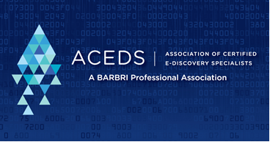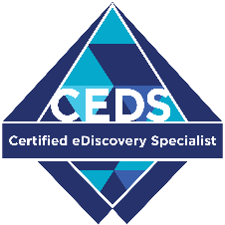

FOR IMMEDIATE RELEASE
Contact:

Local professional awarded prestigious designation for proficiency in legal electronic discovery

[City, State], [Date], [Recipient’s Name] of [city]-based [Company name] has joined a select group of electronic discovery professionals from around the world in achieving the prestigious CEDS (Certified E-Discovery Specialist) designation.

The CEDS credential validates the proficiency of professionals who have demonstrated their knowledge by passing a four-hour examination which serves as a tough and objective measure of mastery in the challenging field of e-discovery. The certification program is administered by the Association of Certified E-Discovery Specialists (ACEDS), the premier global e-discovery professional membership organization. Since the exam was first offered in November 2010, professionals across 20 countries have earned the CEDS credential.

The CEDS certification verifies an individual’s e-discovery competence and knowledge regardless of their professional specialization. Among the CEDS designees are lawyers, litigation support staff, records managers, information technology (IT) specialists, technology officials, court personnel, paralegals, and consultants. The credential is an assurance to employers, colleagues, and clients that the CEDS-certified professional is serious about efficiency, cost-effectiveness, and risk reduction in all phases of e-discovery.

“The CEDS certification is a strong standard of competence, as proven by success on a rigorous and thorough exam. You don’t just pay money and pass the test. This helps solve my hiring problems." said Alvin Lindsay, a partner at the international law firm, Hogan Lovells, in Miami, who sits on the ACEDS Advisory Board and is often quoted in the media in matters regarding technology, litigation, and electronic evidence.

CEDS exam is offered and recognized worldwide
The proctored CEDS certification exam is offered at over 1,100 secure Kryterion Testing Centers worldwide and via online proctoring. The exam has been created and maintained by a team of over 50 leading e-discovery professionals under the guidance of ACEDS management. During its creation and subsequent revisions, a full psychometric analysis has been conducted to ensure the CEDS exam is technically sound and legally defensible. The rigorous computer-based examination includes 145 scenario-based items, and CEDS candidates receive results upon completion. For more information on CEDS certification and the exam, contact ACEDS Customer Service by email at customerservice@aceds.org or by telephone at 844-992-2337.

